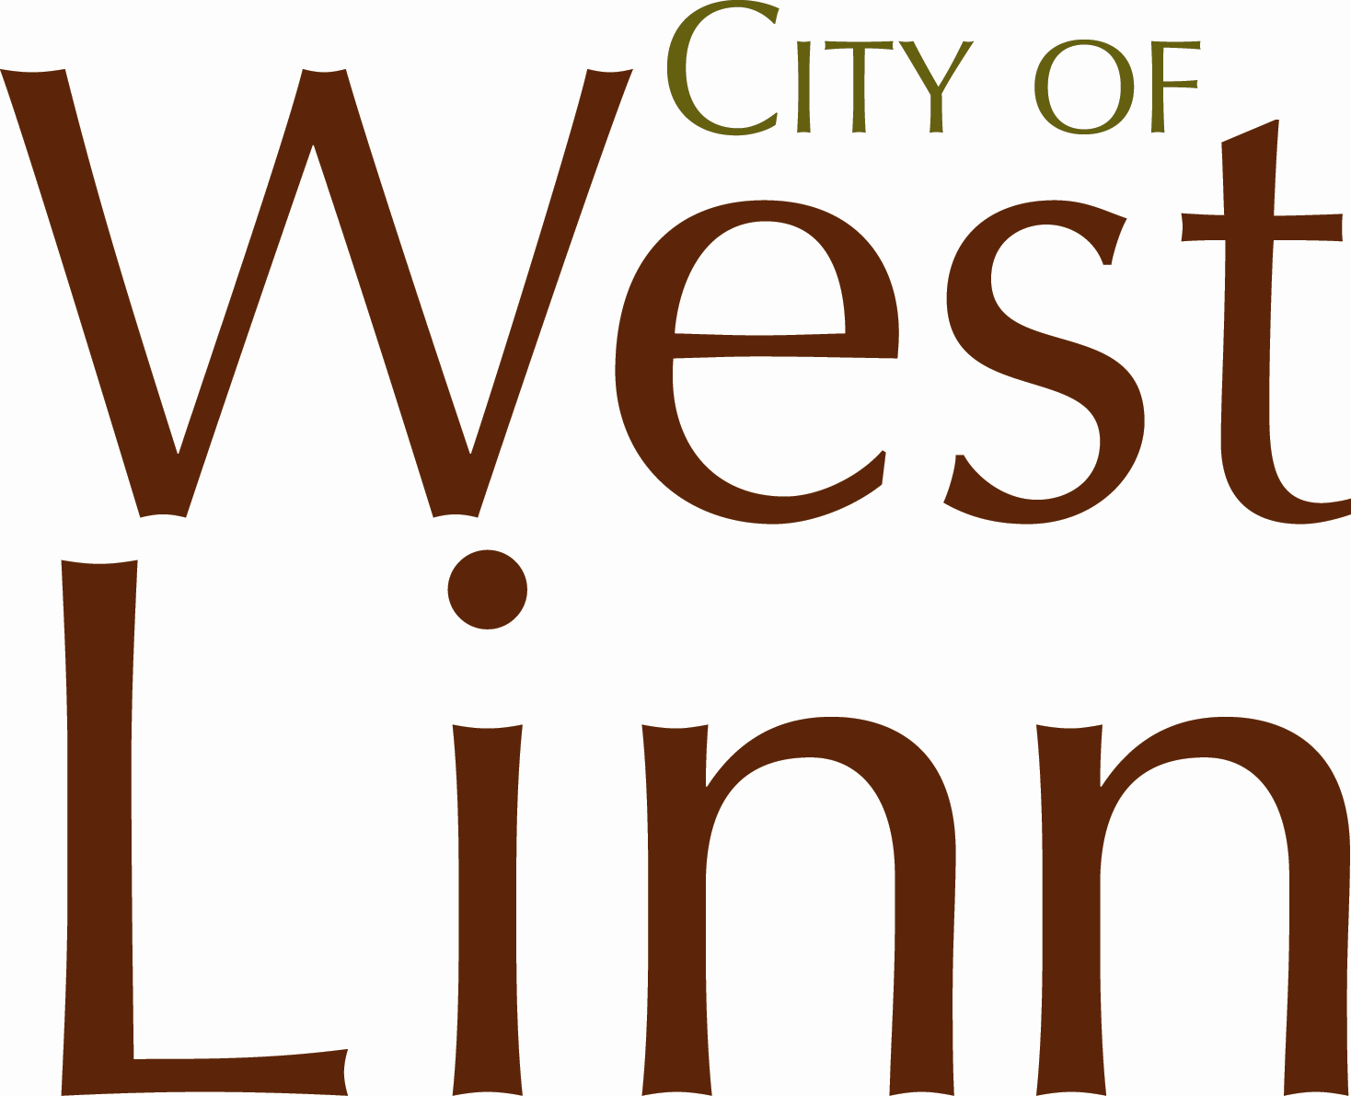PUBLIC IMPROVEMENT
E N G I N E E R I N G
ENGINEERING PLAN REVIEW AND CONSTRUCTION PERMIT
22500 Salamo Rd. Box 800; West Linn, OR 97068

Phone: (503)722-5500 Fax: (503)742-8652

Email: cwl_rowpermits@westlinnoregon.gov

PROJECT NAME AND INFORMATION
Project Name:
Address:

City: | West Linn |  |  |  | State: | OR | Zip: | 97068
Tax Lot:
Map No.:
APPLICANT INFORMATION
Applicant Name:
Address:

City: |  |  |  |  | State: |  | Zip:
Phone: |  |  |  |  | Fax:
Email:

DEVELOPER INFORMATION
Same As Applicant
Developer Name:
Address:
City: |  |  |  |  | State: |  | Zip:
Phone: |  |  |  |  | Fax:
Email:
OWNER INFORMATION
Same As Applicant
Owner Name:
Address:
City: |  |  |  |  | State: |  | Zip:
Phone: |  |  |  |  | Fax:
Email:

DESIGN ENGINEER INFORMATION
Same As Applicant
Engineer Name:
Address:
City: |  |  |  |  | State: |  | Zip:
Phone: |  |  |  |  | Fax:
Email:
CONSTRUCTION COST ESTIMATE
Traffic Control | $
Erosion Control | $
Public Street Improvements | $
Public Storm Drainage Imprvmt. | $
Public Sanitary Sewer Imprvmt. | $
Public Water/Fire Improvement | $

CONSTRUCTION COST ESTIMATE
Street Signs | $
Striping | $
Street Trees | $
Street Lights | $
New Franchise Utilities | $
Underground Existing Utilities | $
PERMIT FEES AND DEPOSITS
Total Construction Estimate | $ 0.00
Review/Inspection Deposit (6%) | $ 0.00
Administrative Fee | $ 90.00
Total Fees and Deposits | $ 0.00

PUBLIC WORKS – ENGINEERING DIVISION - STAFF ONLY
Deposit and Fee Received: | $ |  | Receipt Number:
Public Improvement Permit #:
Planning Dept. Project #’s:
Approved Permit Issued By: |  |  |  | Permit/Plan Approval Date:
Please submit all necessary reports and one full construction plan consisting of the following for review and approval: Note: Separate Erosion Control and Building Dept. Permits shall be required (for lot grading, erosion control, tree protection, and private plumbing).
CONSTRUCTION PLANS | Storm Drainage Improvement Plan and Profile page(s)
Cover page | Sanitary Sewer Improvement Plan and Profile page(s)
Public Improvement Permit page | Water/Fire Improvement Plan and Profile page(s)
Planning Conditions of Approval page(s) | Landscaping Plan for all storm drainage facilities page(s)
General Construction Notes page(s) | Street Tree Plan page(s)
Existing Conditions page(s) | Street Lighting Plan page(s)
Preliminary Plat page(s) | PGE and Franchise Utilities Plan page(s)
Demolition Plan page(s) | West Linn Standard Details page(s)
Grading and Erosion Control Plan page(s) | REPORTS
Street Improvement Plan and Profile page(s) | GEOTECHNICAL REPORT
Street Cross Section page(s) | FINAL TRAFFIC REPORT
Street Sign Plan page(s) | FINAL STORM DRAINAGE REPORT
Street Striping Plan page(s) | FIRE FLOW CALCS

ATTENTION: Oregon law requires you to follow rules adopted by the Oregon Utility Notification Center. Those rules are set forth in OAR 952‐001‐0010 through OAR 952‐001‐0090. You may obtain copies of the rules by calling the center. (Note: the administrative telephone number for the Oregon Utility Notification Center is (503) 232‐1987). Locate requests shall be made 48 hours prior to any work taking place. The one call number for utility locates is (503)246-6699 or 811.

This permit is issued for construction within the public right of way and/or easements as described upon the attached plans. This permit is issued subject to the following conditions:
- I understand that the City’s sole function is to review the plans and inspect the work to assure compliance with City code and that the City assumes no responsibility of any kind for the accuracy or suitability of the work submitted. I accept full responsibility for compliance with all applicable city, state, regional, and federal laws, ordinances, franchise agreements, regulations, and codes which apply to the work for which this permit is issued.
- I agree to ensure that all construction will conform to the most current City of West Linn Public Works Construction Standards, the City-approved construction drawings, all specific conditions of approval, any on-site revisions required by the City Engineer, and all other applicable City of West Linn Code including, but not limited to, City Ordinances, the City Municipal Code and the City Community Development Code. I agree to inform all contractors, subcontractors, or any other persons performing work under this permit of the provisions of this permit and assure their compliance with those provisions.
- I agree to allow access by City employees or its representatives to the property where construction is being performed.
- I agree to hold the City of West Linn and its employees harmless from any and all damages or expenses caused by work under this permit and hereby accept all liability for damage to persons and/or property caused in the process of completing this work.
- I agree to restore the work area or any areas damaged in the course of work to original or better condition, current codes, and to City Engineer satisfaction and to pay all costs to repair or replace any property damaged while work is being performed under this permit and acknowledge that failure to pay these costs when due will constitute a violation of the terms of the permit and the City may avail itself to any and all legal remedies.
- A performance security and proof of insurance citing the City as additionally insured per City requirements must be submitted and approved by the City Engineer prior to starting construction. An 18 month maintenance security after final approval is required on all work within the public right-of-way and easements per City code.
- The construction plans have been stamped and signed by a Registered Professional Engineer actively licensed to practice in the State of Oregon.

By my signature below I certify that I have read the foregoing conditions under which the permit is issued, am duly authorized to represent Developer and/or Owner, and do hereby agree to comply with those conditions and any additional conditions of approval following processing of the permit. Work may not start until plans are reviewed and approved by the City.

Applicant Signature:
Print | Signature | Date

