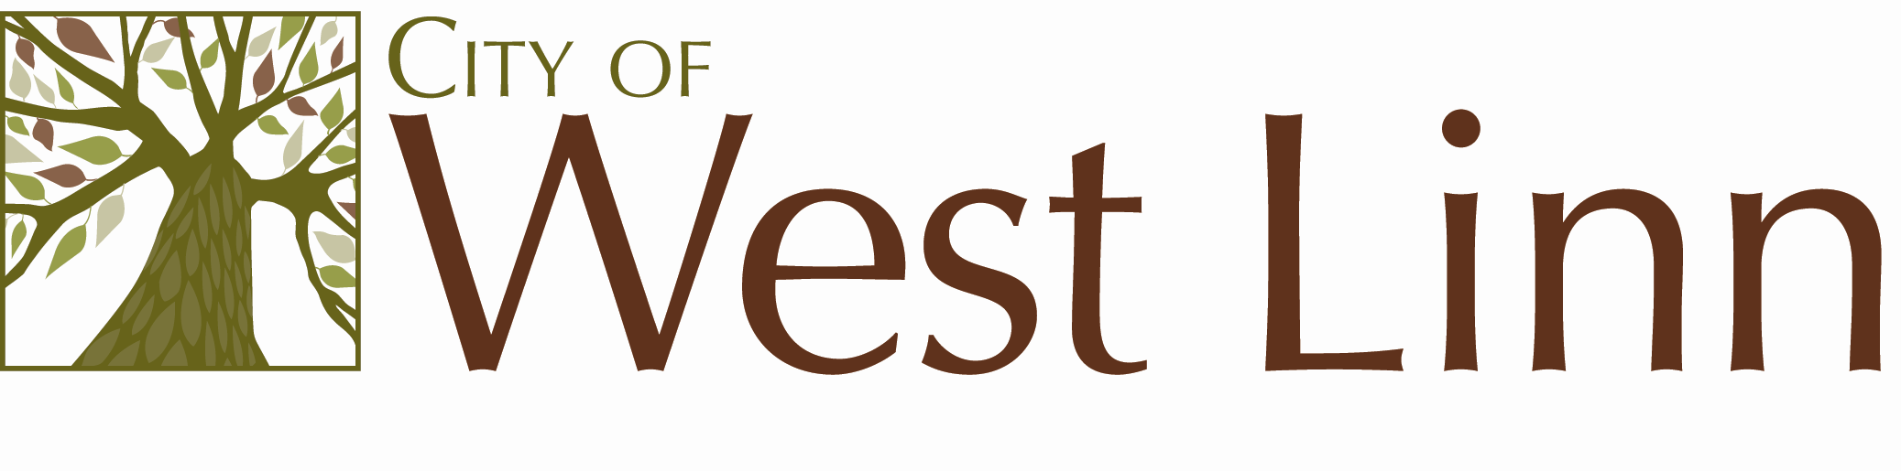22500 Salamo Rd.
West Linn OR 97068
www.westlinnoregon.gov

WEST LINN

MEETING NOTICE

Utility Advisory Board

Tuesday, July 12, 2011

6:00 to 7:00pm

Council Chambers
West Linn City Hall
22500 Salamo Rd
West Linn, OR 97068

