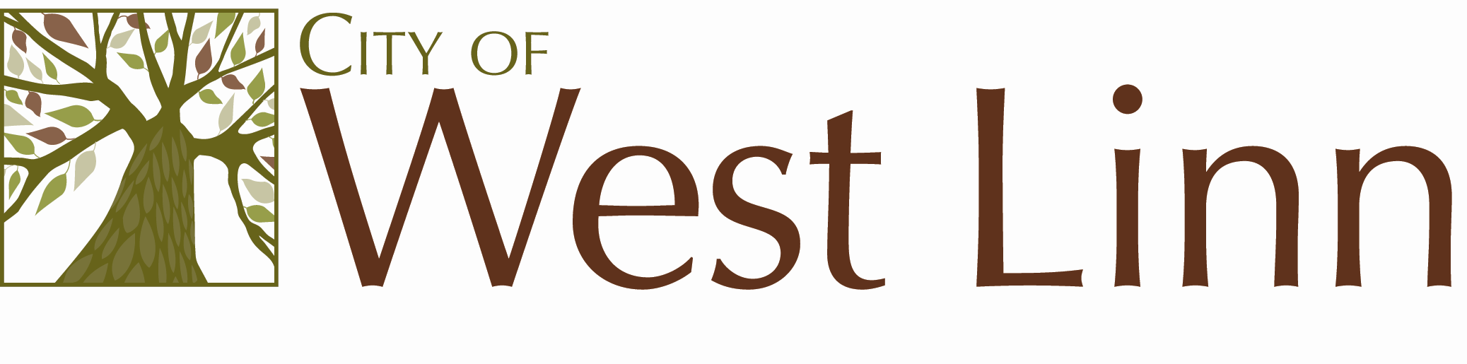
22500 Salamo Rd.
West Linn OR 97068
www.westlinnoregon.gov

WEST LINN

MEETING AGENDA

Utility Advisory Board

July 12, 2011

6:00 - 7:00pm

Council Chambers
West Linn City Hall
22500 Salamo Rd
West Linn, OR 97068

- Call to Order and Introduction

- Approve May 10, 2011, Summary Notes

- Discuss questions with the Finance Director.

- Adjournment

