22500 Salamo Rd.

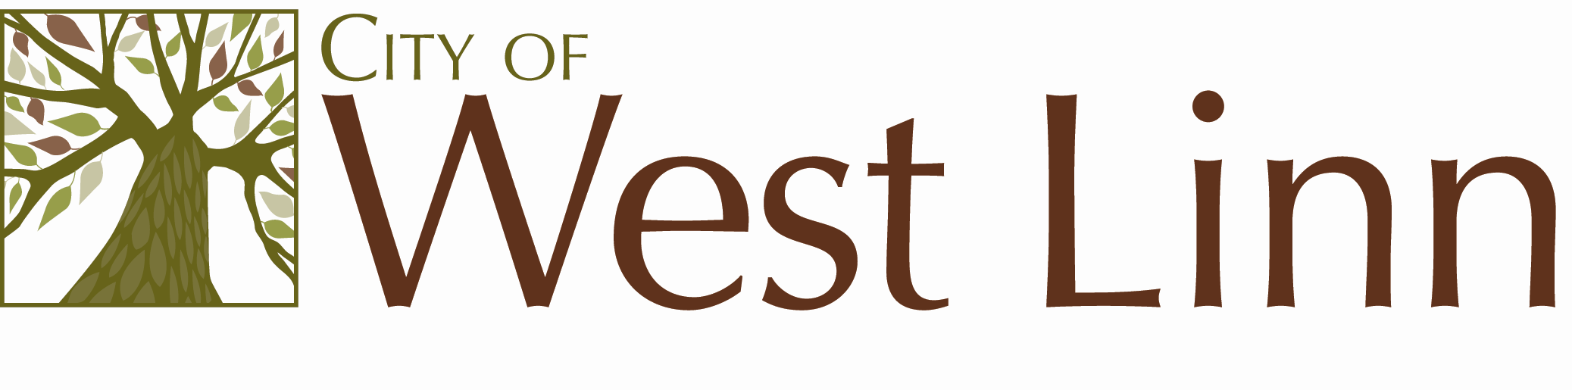

West Linn OR 97068

[www.westlinnoregon.gov](http://www.westlinnoregon.gov)

**WEST LINN**

**MEETING NOTICE**

**Utility Advisory Board**

Wednesday, January 19, 2011

6:00 to 7:00pm

South Fork Water Board

15962 S. Hunter Ave.

Oregon City, OR

503.657.5030