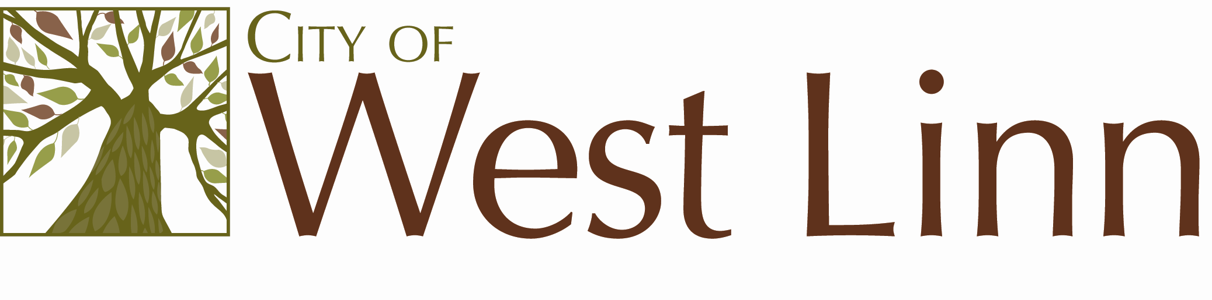
22500 Salamo Rd.
West Linn OR 97068
www.westlinnoregon.gov

WEST LINN

MEETING AGENDA

Utility Advisory Board

March 8, 2011

6:00 - 7:00pm

Council Chambers
West Linn City Hall
22500 Salamo Rd
West Linn, OR 97068

- Call to Order and Introduction (brief background history)

- Approve February 16th, 2011, Summary Notes

- Nominations of Officers

- Discuss City Council directives:
Water Infrastructure Maintenance
Water Rate Increase

- Adjournment

