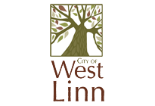

22500 Salamo Rd.
West Linn OR 97068
www.westlinnoregon.gov

WEST LINN
ECONOMIC DEVELOPMENT COMMITTEE
______________________________________________________________________________________________
Dec. 1, 2015
8:00 AM
Bolton Room, City Hall
___________________________________________________________________________________________________

No Minutes due to a lack of a quorum.

