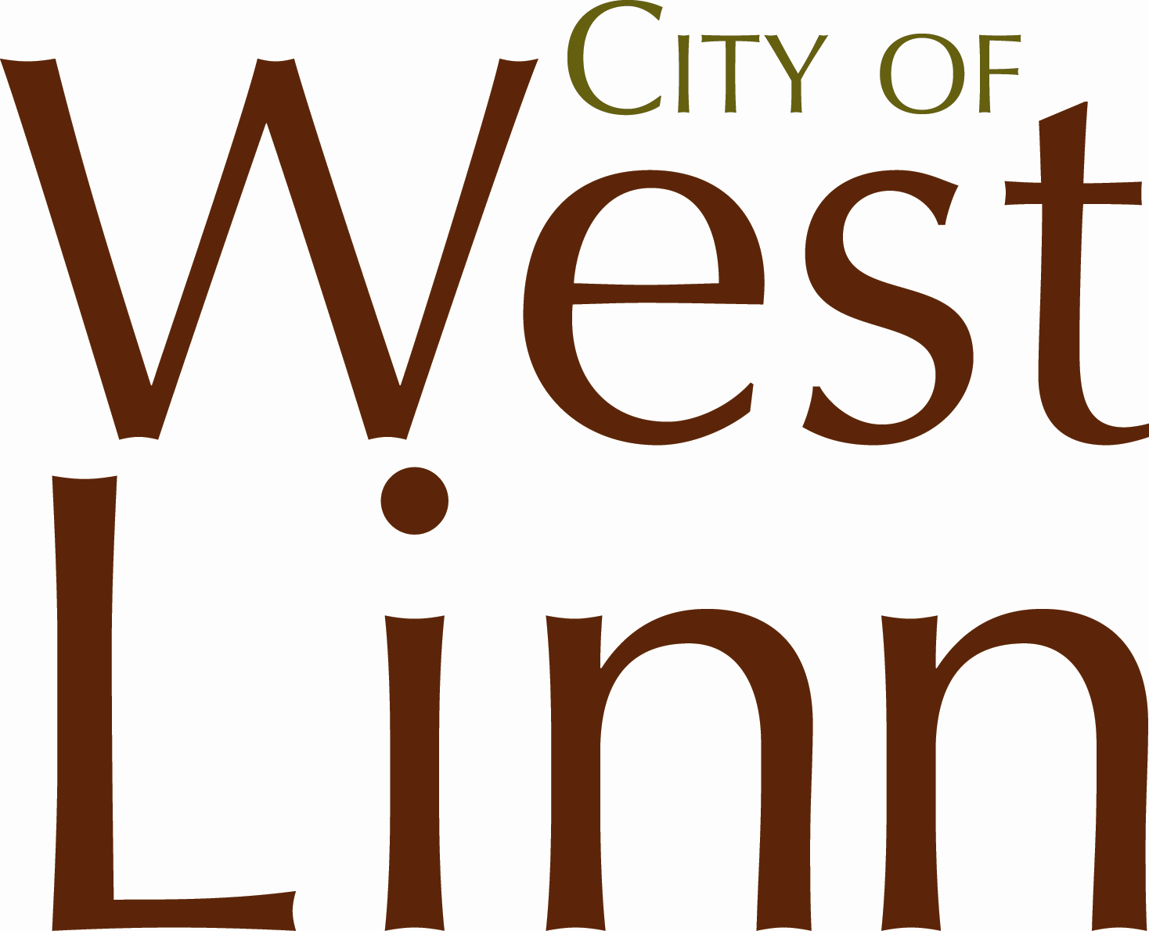 PUBLIC WORKS PERMIT
E N G I N E E R I N G
For work within City Public Right-of-Way or Easements

Inspection Request: westlinnoregon.gov/publicworks/engineering-inspection-request

22500 Salamo Rd. Box 800; West Linn, OR 97068; Ph: (503)722-5500 Fx: (503)656-4106

Email: cwl_rowpermits@westlinnoregon.gov
PERMIT #

PROJECT LOCATION:
+
WORK DESCRIPTION:
After Approval Return to (specify email, fax, mail address):
PROPERTY OWNER / FRANCHISE UTILITY
Applicant Name:
Utility Name:
Address:
City:  Weeeeee |  |  |  |  |  | State: |  | Zip:
Phone: |  |  |  |  |  | Fax:
Email:

Plans included

CONTRACTOR
Business Name:
Address:

City: |  |  |  |  |  | State: |  |  | Zip:
Phone: |  |  |  |  |  | Fax:
CCB: |  |  |  |  |  | City/Metro lic.
Email:
24 Hour Emergency #

WORK INCLUDES (check all that apply):
Street cut Size a' X b' | Sidewalk/approach/curb |  | Pipe bore | Trench | Pipe tap | Disturb landscape

ATTENTION: Oregon law requires you to follow rules adopted by the Oregon Utility Notification Center. Those rules are set forth in OAR 952‐001‐0010 through OAR 952‐001‐0090. You may obtain copies of the rules by calling the center. (Note: the administrative telephone number for the Oregon Utility Notification Center is (503) 232‐1987). Locate requests shall be made 48 hours prior to any work taking place. The one call number for utility locates is (503)246-6699 or 811.

PERMIT CONDITIONS:
- I understand that the City’s sole function is to review the plans and inspect the work to assure compliance with City code and that the City assumes no responsibility of any kind for the accuracy or suitability of the work submitted. I accept full responsibility for compliance with all applicable city, state, regional, and federal laws, ordinances, franchise agreements, regulations, and codes which apply to the work for which this permit is issued.
- I agree to inform all contractors, subcontractors, or any other persons performing work under this permit of the provisions of this permit and assure their compliance with those provisions. I agree to ensure that all construction will conform to the City’s Public Works Construction Standards, the approved construction drawings, all specific conditions of approval, and any on-site revisions required by the City Engineer.
- I agree to allow access by City employees or its representatives to the property where construction is being performed.
- I agree to hold the City of West Linn and its employees harmless from any and all damages or expenses caused by work under this permit and hereby accept all liability for damage to persons and/or property caused in the process of completing this work.
- I agree to restore the work area or any areas damaged in the course of work to original or better condition, current codes, and to City Engineer satisfaction and to pay all costs to repair or replace any property damaged while work is being performed under this permit and acknowledge that failure to pay these costs when due will constitute a violation of the terms of the permit and the City may avail itself to any and all legal remedies.
- I understand that an 18 month warranty after final approval is required on all work within the public right-of-way and easements per City code.
- This permit shall be void if work is not completed within six months of permit issuance.

By my signature below I certify that I have read the foregoing conditions under which the permit is issued, am duly authorized to represent contractor, utility company, and/or owner, and do hereby agree to comply with those conditions and any additional conditions of approval following processing of the permit. Work may not start until plans are reviewed and approved by City.

Print Authorized Signature Date
*Minimum 24 hour notice required prior to work and for all inspection requests. Please allow 3-5 days for processing*

FEES
Admin. fee | $ 50
Review/Inspection Deposit | $ 500
Street Cut Deposit ( linear ft. X $50)+$500= | $ 0
Driveway approach dep. ( ft. X$50)+$500= | $ 0
TOTAL: | $ 550

