Date: November 17, 2014
To: Project Management Team
From: Noah Brennan, Associate Engineer, EIT; Zach Pelz, Associate Planner
Subject: Draft Technical Memorandum No. 2: Transportation Changes Since 2008 and Special Interest Topics

This memo documents changes to West Linn’s transportation system that have occurred since the adoption of the 2008 Transportation System Plan (TSP). This memo also introduces topics of special interest that will be considered as part of the updated TSP.

Transportation Improvements Since 2008
Since 2008, a total of 39 transportation improvements have been completed as part of 32 discrete improvement projects (see Table 1 below). Of the 32 projects, 26 have been completed by private developers as improvements associated with land development, while six have been completed by the City as part of its Capital Improvement Program. A significant majority of the transportation improvements have been sidewalk infill projects, in addition to six bicycle infrastructure improvements and three new pedestrian crossings. The City is currently in the process of finalizing the installation of a new traffic signal at the intersection of Salamo and Rosemont Roads. The gray shaded projects in Table 1 represent projects identified in the 2008 TSP master plans. Many of the improvements are only portions of the complete project.

Figure 1 West Linn Pedestrian Plan (2008 TSP)
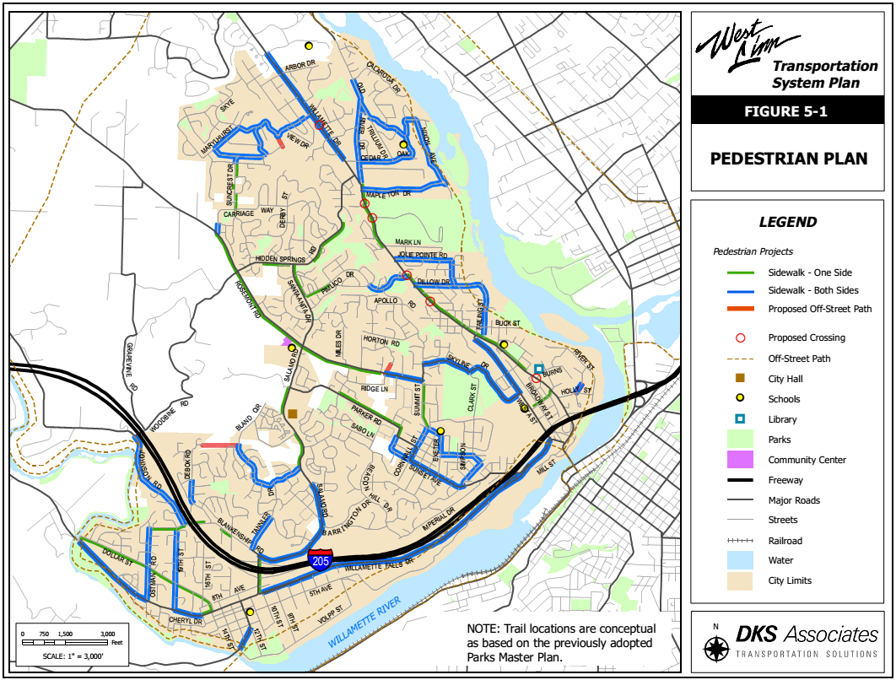

Figure 2 West Linn Bicycle Plan (2008 TSP)
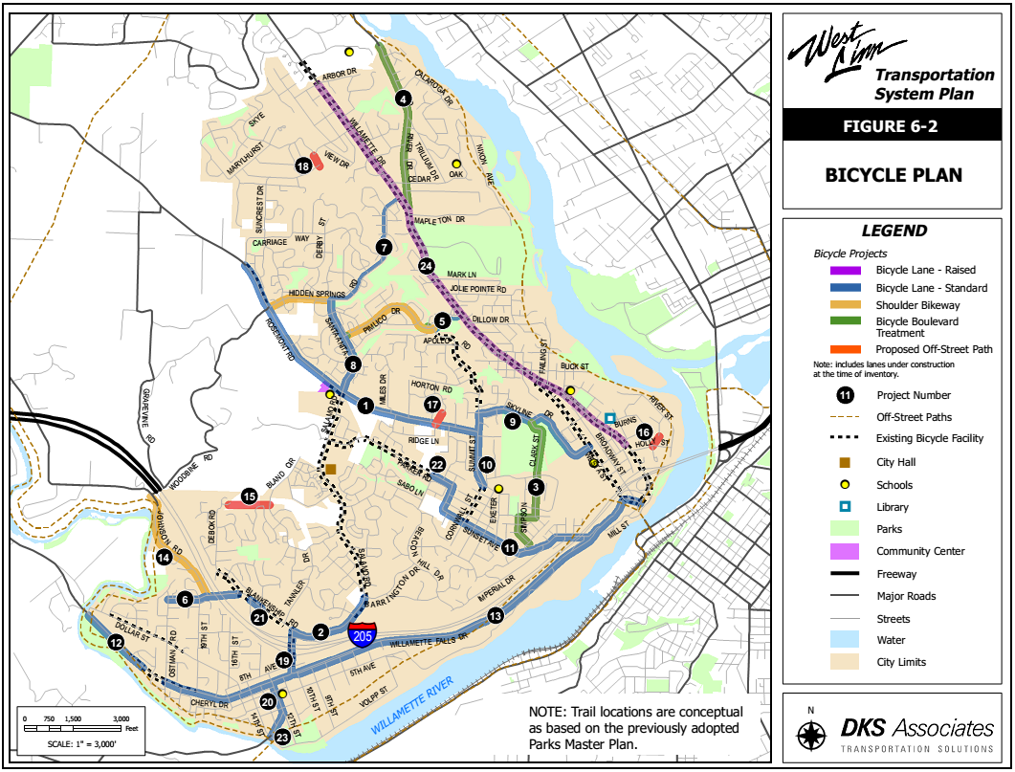
Table 1 Transportation System Changes Since 2008
 |  | Sidewalk infill | Bikeways | Traffic Signals
Project No. | Project Title |  |  |  | Project Description
PW-14-02 | Road Program 2014 |  | x |  | Widened Blankenship Rd to include bike lane between Johnson Rd and Debok Rd
PW-14-11 | Holmes St Sidewalk Improvement | x | x |  | Extended Sidewalk along Holmes St to Bolton Primary School
PW-14-05 | Bland Waterline Interconnect | x |  |  | Sidewalk along Salamo from Bland Circle to Weatherhill Rd
PW-13-14 | Santa Anita & Rosemont Intersection |  |  | x | New Signal at intersection
PI-14-02 | Harper Subdivision | x |  |  | Sidewalk, Gloria Dr and Summit St to Woodsprite Ct
PI-14-02 | Weatherhill Subdivision | x |  |  | Creation of street and sidewalk on Satter St off of Weatherhill Rd, pedestrian path connecting to Bland Circle
PI-13-10 | Sunbreak Subdivision | x |  |  | Street and sidewalk connection of Crestview Dr, Sunbreak Lane and Bland Circle, pedestrian crossing of Bland Circle, pedestrian path from Sunbreak Lane to Crestview lots
PI-13-09 | Rosemont Subdivision | x |  |  | Sidewalk added on Rosemont frontage between 1473 and 1499 Rosemont Rd
PI-13-07 | Benjamin Heights Partition | x |  |  | Sidewalk along frontages on NW side of Salamo Rd and Remington Dr intersection
PW-14-07 | 8th Ave Across from police department | x |  |  | Sidewalk from frontage of fire department on 8th Ave
PI-13-06 | Police Station | x |  |  | Sidewalk along north side of 8th Ave and east side of 13th St
PI-13-03 | Falcon Place | x |  |  | Sidewalk along Bland Circle across from Falcon Dr
PI-13-02 | West Linn High School Parking Lot | x |  |  | Sidewalk added on Skyline Dr
PI-12-03 | Chase Bank-Highway 43 | x |  |  | Sidewalk improvements along Highway 43 Frontage
PI-12-01 | Ostman Rd MIP | x |  |  | Sidewalk on west side of Ostman from Michael Dr to Royal Court, and first lot of North side of Michael Dr
PI-11-03 | Suncrest Subdivision |  |  |  | Sidewalk on Suncrest Dr frontage 19638, 19650 & 19656 Suncrest Dr
PI-11-02 | Teresa's Vineyard | x |  |  | Completion of Coeur d'Alene Dr, and sidewalk
PI-11-01 | Trillium Creek Primary School-Rosemont Rd | x | x |  | Sidewalk improved and replaced along Rosemont Rd widening, bike lane added
PI-10-09 | Marylhurst Heights Park | x |  |  | Paved path through park
PI-10-01 | Debok Subdivision | x |  |  | Added Debok Ct. street and sidewalk off of Wisteria Rd
PW-09-10 | Blankenship Sidewalk Improvement | x | x |  | 2 Pedestrian crossings on Blankenship, and sidewalk and Bike lane on south side of Blankenship between Virginia Ln and Albertson’s frontage.
PI-09-04 | Cedar Oak School | x |  |  | Sidewalk improvement along school frontages on Cedaroak Dr
PI-09-03 | Willamette Fire Station #59 Tualatin Valley Fire & Rescue | x |  |  | New sidewalk along 8th Ave frontage
PI-09-02 | Willamette Fire Station #58 - Tualatin Valley Fire & Rescue | x |  |  | New sidewalk along Elliott St, Buck St, and Failing St
PI-09-01 | Berlin Bear - ROW Work | x |  |  | Sidewalk replacement, no addition
PI-08-07 | LDS West Linn Ward Church | x | x |  | Sidewalk along Rosemont Rd and Shannon Ln frontages, and sidewalk connection to Miles Dr from Rosemont Rd.
PI-08-06 | Fairview Acres | x | x |  | 75' of asphaltic-concrete sidewalk on Fairview Way
PI-08-04 | Willamette Christian Church - Street and Storm | x |  |  | New sidewalk along west side of Salamo Rd along property frontage and ramp across what is now Brandywine Dr
PI-08-03 | Willamette Village Site Work | x |  |  | Sidewalk along Willamette Dr (Highway 43)
PI-07-14 | Bella Flats Subdivision | x |  |  | Sidewalk added along Elmran Dr
PI-07-10 | Shannon Lane Partition | x |  |  | Sidewalk added along northern 2 lots of Shannon Lane
PI-07-05 | Douglas Park Subdivision | x |  |  | Sidewalk added along Haskins Rd 700' SE and Rogue Way from Lois Ln to Haskins Rd

TSP Special Interest Topics
Next Steps for Old Willamette Area to Improve Parking Management
In 2013, the City of West Linn assembled a task force comprised of residents, business owners, and Citizen Advisory Board members to discuss issues related to parking in the City’s Willamette Commercial District; which comprises an area immediately north and south of Willamette Falls Drive between 14th St and 10th Street, properties immediately north and south of 8th Avenue between 14th Street and 10th Street and properties east and west of 10th Street south of I-205.^{t}. A staff parking analysis found, and the task force later agreed, that parking was currently adequately supplied during most times of the year, except during special events held in the Commercial district. The Task Force recommended five, relatively modest, strategies to address parking supply needs during special events, including:
- Identify areas for employee parking that are off of Willamette Falls Drive and ensure safe access to employers;
- Improve parking for special events;
- Assign a City staff liaison to meet with local business owners on a quarterly basis;
- Improve user information and marketing; and
- Provide enhanced parking enforcement as resources permit.
The TSP will decide how and when these strategies are funded and implemented.

Mode Share Targets for Key Destinations, Such as Employment and Shopping Areas and Schools, Based on City’s Metro 2040 Design Types
Between 2006 and 2010, more than 76 percent of West Linn residents commuted to jobs outside of the City using a single-occupant vehicle. Because of the need to improve the efficiency of the region’s transportation system, the Regional Transportation Functional Plan (RTFP) establishes a non-SOV target of between 40 and 55 percent for Regional and Town Centers, Corridors, and Industrial and Employment areas, by the year 2035. This means that by 2035, residents living in the Highway 43 Corridor in West Linn, the Bolton and Willamette Town Center areas, and in the Willamette Main Street Area, will be expected to drive alone at a rate 15 to 30 percent less than today.

Transit Supportive Land Uses
The Regional Transportation Plan (RTP) emphasizes a more balanced approach to transportation problem solving than the historically automobile-centric focus that has been the norm in the United States for the past five decades. Effective public transit, transit that is convenient and that encourages choice riders (riders who have a choice to use public transit or drive alone); however, relies on a minimum threshold of residential and employment density to make it economically viable for the transit provider. It is important to consider the land use and density requirements necessary to serve public transit when planning for these modes as solutions to regional transportation challenges.
The current literature suggests the following minimum densities necessary to support various levels of public transit:

Table 2 Minimum Land Densities Supporting Transit Service at Various Frequencies (

Transit Service | Minimum Residential Density | CDB Commercial/Office Density
Local bus, 1 bus/h | 4.5 dwelling units/net acre | 5-8 million ft²
Local bus, 2 bus/h | 7 dwelling units/net acre | 8-20 million ft²
Local bus, 6 bus/h | 15 dwelling units/net acre | 20-50 million ft²
Light rail, 5-min peak headway | 9 dwelling units/net acre in 20-100 mi² corridor | 30-50 million ft² (20 million ft² if 100% at grade)
Rapid transit, 5-min peak headway | 12 dwelling units/net acre in 100-150 mi² corridor | >50 million ft²
Commuter rail, 20 trains/day | 1-2 dwelling units/net acre | >100 million ft²

Additionally, research suggests that the availability of public transit within walkable neighborhoods promotes fewer vehicle miles traveled per capita and more walking, biking and public transit use.

Table 3 Land Use Impacts on Vehicle Ownership (Portland 2009)
Land Use Type | Auto Ownership | Daily VMT | Mode Split
 | Per Household | Per Capita | Auto | Walk | Transit | Bike | Other
Good transit/Mixed use | 0.93 | 9.8 | 58% | 27% | 12% | 1.9% | 1.5%
Good transit only | 1.50 | 13.3 | 74% | 15% | 7.9% | 1.4% | 1.1%
Remainder of county | 1.74 | 17.3 | 82% | 10% | 3.5% | 1.6% | 3.7%
Remainder of region | 1.93 | 21.8 | 87% | 6.1% | 1.2% | 0.8% | 4.0%

Alternatives to Automobile Level of Service and Volume-to-Capacity Standards
Transportation systems can be evaluated in various ways that reflect different perspectives concerning uses, modes, land use, transport problems and solutions, how transport activity is measured, and the type of performance indicators used (Litman, 2011). Historically, transportation system plans have evaluated performance using Level-of-service or Volume to Capacity metrics. Both metrics assume that travel and trips mean vehicle trips and improvements in system quality come about by increased vehicle mileage and speed (Litman, 2011).
Transportation system performance can however, be measured in other ways that place more emphasis on mobility and or accessibility. Mobility measurements consider automobiles as the most important since people and goods are moved primarily by automobile. A mobility perspective, however, recognizes that some people use non-automobile modes. Mobility can be measured through surveys to quantify person-miles and travel speeds in conjunction with traffic data to quantify average automobile and transit vehicle speeds. In recent years, techniques to evaluate bicycle and transit level-of-service have emerged (Litman, 2011).
Finally, transportation system performance can be measured from an accessibility perspective; where reaching goods, services, activities and destinations are the primary goal, regardless of travel mode. From this perspective, land use is as important as mobility in the quality of transportation, and different land use patterns favor different types of accessibility (Litman, 2011). From this perspective, transportation system performance can be evaluated based on the time, money, discomfort and risk required to reach opportunities (Litman, 2011).

Table 4 Various Transportation Performance Measurement Units (adapted from Litman, 2011)
Measurement unit | Description
Vehicle-mile | Reflects a traffic perspective that places high value on automobile travel
Passenger-mile | Reflects a mobility perspective that values automobile and transit travel, but gives less value to non-motorized modes because they tend to be used for short trips
Per-trip | Reflects an access perspective which gives equal value to automobile, transit, cycling, walking and telecommuting
Travel time | Reflects an access perspective with higher priority to walking, cycling and transit travel because they tend to represent a relatively large portion of travel time
Generalized costs | Reflect an access perspective

Outcomes-based, Performance-driven Planning at Metro
Cities and States across the US are facing a transportation dilemma: 1) transportation infrastructure is reaching the end of its useful life and requires significant maintenance and/or replacement, 2) transportation funding is becoming more and more scarce, 3) the cost to make transportation improvements is increasing rapidly, and 4) population in metropolitan areas is on the rise, placing more demand on transportation systems. For these reasons, and because citizens are becoming increasingly sensitive to government spending, transportation systems must work to become as efficient and effective as reasonably possible.
Metro’s 2035 Regional Transportation Plan (RTP) identifies six outcomes that are at the core of future investment:
- Vibrant communities
- Economic prosperity
- Safe and reliable transportation
- Leadership on climate change
- Clean air and water
- Equity
The RTP performance targets are tied to a framework of economy, environment, and equity and set measurable targets to evaluate the region’s future success. Table 5 presents a sample of regional performance targets.

Table 5 Sample Policy-level Performance Targets (Metro, 2010)
 | Target
Economy | Congestion – by 2035, reduce vehicle hours of delay per person by 10 percent compared to 2005
 | Freight reliability – by 2035, reduce vehicle hours of delay per truck trip by 10 percent compared to 2005
Environment | Active transportation – by 2035, triple walking, biking and transit mode share compared to 2005
 | Clean air – by 2035, ensure zero percent population exposure to at-risk levels of air pollution
Equity | Access to daily needs – by 2035, increase by 50 percent the number of essential destinations accessible within 30 minutes by bicycling and public transit for low-income, minority, senior and disabled populations compared to 2005

