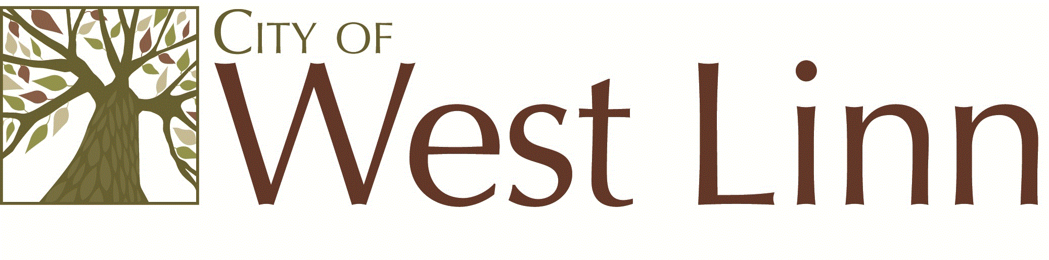

Date: November 12, 2014
To: Project Management Team
From: Zach Pelz, Associate Planner and Gail Curtis, Senior Planner, ODOT
Subject: Draft City of West Linn Transportation System Plan Policy Framework, Tech Memo 1

This memorandum outlines the applicable policy and regulation for the City of West Linn Transportation System Plan (TSP) update. The TSP is being carried out by the City of West Linn with consultant assistance between fall, 2014 and fall, 2015. The policy framework has been prepared for the Project Management Team, Planning Commission, City Council, partner agencies and interested citizens.

The first section of the attached report describes the relationship of the applicable policies. The next section is the City of West Linn’s current transportation and land use policies; followed by the Metro regional policies and regulations. The Metro policies and regulations are the primary driver behind the City’s TSP update. They include specific regulatory actions and targets that the City must comply with. This section is followed by agency and service provider policies and lastly, the Oregon Planning Guidelines that are the statewide goals from which the regional and local policy flow.

Oregon’s Transportation System Planning
Integration and Consistency
Regional Plan
Oregon Statewide Planning Goals

Goal 12 Transportation Planning Rule (TPR) requires TSPs to plan for a balanced, multi-modal system that complies with state and regional goals, polices and regulations in order to reduce reliance on single-occupant vehicles amongst other objectives.

Oregon Transportation Plan and related modal plans (highway, bike, rail, safety, etc.) are the state’s TSP.
Metro Functional Plan Regional Transportation Plan

Local Plans

City of West Linn
Comprehensive Plan
Transportation
System Plan

Clackamas County Comprehensive Plan Transportation
System Plan

The TSP update is mandated as part of Oregon’s Transportation Planning Rule (TPR) and must be consistent with adopted state and regional transportation and land use plans and policies.

The TSP policy framework will influence the selection of solutions and investments included in the TSP. While the State of Oregon’s statewide planning and Portland Metro regional planning provide a strong policy and regulatory framework, the most relevant policy is the adopted, local policy which is expressed by the City of West Linn Comprehensive Plan and Imagine West Linn. The TSP update is expected to result in new or modified City policy and implementing regulations in order to be in compliance with regional policy. Since the regional transportation and land use policies and regulations have been deemed consistent with state policy, regional policy becomes the focus of compliance for the TSP update.
Below is an overview the City policies relevant to the TSP.

West Linn Comprehensive Plan

The West Linn Comprehensive Plan guides local land use decisions by establishing policies that implement Statewide Planning Goals and regional policy. Goal 12, the City’s comprehensive plan transportation goal, identifies policies and actions the City will pursue to implement the TSP and the transportation-related guidance established in the State Planning Guidelines. This goal and related implementing regulations express how the City has chosen to become “consistent” with the relevant state and regional policies and regulations. A review of missing or incomplete City policies and implementing regulations will be identified as part of the TSP update.

Key City of West Linn Comprehensive Plan policies for the TSP Update include:
- Goal 12, Policy 1: Protect the entire rights-of-way of existing City streets for present and future public use;
- Policy 2: Design and construct transportation facilities to meet the requirements of the Americans with Disabilities Act;
- Policy 3: Require in-fill development in older neighborhoods to contribute to needed transportation facilities within their neighborhoods to the extent allowed by law;
- Policy 4: Improve traffic safety through a comprehensive program of engineering, education and enforcement;
- Policy 5: Take a more aggressive and proactive role in assuring federal, state, and regional decision makers consider West Linn’s needs for improvements to I-205;
- Policy 6: Recognize the Metro designation of green corridors and their function to provide interurban connectivity. If future annexations include a green corridor, control access to the green corridor to maintain the function, capacity, and level of service of the facility and to enhance safety and minimize development pressures on rural reserves;
- Policy 8: Pursue an interconnected street system that provides connections between development and neighborhoods;
- Streets Policy 1: Establish and maintain transportation performance measures;
- Streets Policy 2: Protect neighborhoods from excessive through traffic;
- Streets Policy 6: Strive to maintain a safe and efficient transportation system by developing street standards, access management policies, incorporating traffic calming measures, and by making street maintenance a priority;
- Streets Policy 9: Develop neighborhood and local connections as identified in the West Linn TSP, to provide adequate circulation in and out of the neighborhoods;
- Streets Policy 10: Limit the use of cul-de-sacs and closed street systems;
- Streets Policy 11: Participate in regional discussions and planning for rail service or other modes of transportation that encourages regional transportation;
- Streets Policy 12: Seek funding and prioritize improvements that address: improvements for pedestrians and transit riders; improvements at high accident locations; street maintenance improvements; neighborhood traffic calming; and, improvements for bicyclists;
- Bicycle Policy 2: Promote a comprehensive network of bike paths, lanes, and routes that: connects the four commercial centers in Willamette, Bolton, Robinwood, and Tanner Basin; integrates with regional bicycle routes that traverse West Linn; provides connections to schools, recreation facilities, community centers, and transit facilities;
- Bicycle Policy 3: Stripe and sign bike lanes on all arterial and collector streets consistent with the TSP;
- Bicycle Policy 4: Require new commercial, industrial, and institutional development to provide on-site facilities for bicycle parking and storage; design new streets and retrofit older streets to enhance safety for bicyclists using the roadways;
- Pedestrian Policy 1: Promote a comprehensive network of pedestrian paths, lanes, and routes that connects the City’s commercial centers, provides connections to schools, recreation facilities, community centers, and transit facilities; use off-street pedestrian short-cut pathways to provide routes where physical constraints or existing development preclude the construction of streets with sidewalks; provide safe, secure and desirable walkway routes, with a preferred spacing of no more than 330 feet; eliminate gaps in the existing walkway network and provide pedestrian linkages between neighborhoods;
- Pedestrian Policy 4: Promote safe pedestrian crossings;
- Pedestrian Policy 5: Where parks and recreation trails are coterminous with sidewalks, their design shall be enhanced to serve both transportation and recreational purposes;
- Pedestrian Policy 6: Construct sidewalks on all new streets in West Linn and review they City’s walkway standards periodically to ensure consistency with regional, State and Federal standards;
- Pedestrian Policy 7: The City will enforce regulations requiring developers to include pedestrian facilities and walkway connections within proposed developments and to adjacent land uses and right-of-way in accordance with adopted policies and standards. Developer agreements for the provision of walkways will be implemented and enforced as needed;
- Transit Policy 1: Encourage expanded bus service along existing routes and new transit service to areas that currently are not served by transit;
- Transit Policy 4: Prioritize transit improvements that would increase overall mobility;
- Transit Policy 5: Promote a transit network that connects the City’s commercial centers;
- Transit Policy 6: Establish that fixed route transit will use arterial and collector streets in West Linn;
- Transit Policy 7: Encourage the provision of regional transit service between West Linn and other suburban communities in the Metro Area;
- Transit Policy 8: Encourage the development of modes of mass transit for those residents of the City who must commute to jobs outside the City limits;
- Transit Policy 9: Work with TriMet to implement special needs transportation in accordance with the ADA;
- Transit Policy 10: Improve pedestrian and bike accessibility along major transit routes and to transit stations;
- Transit Policy 11: Support a public transit system that is accessible to the largest number of people by:
  - Locating transit oriented development around transit stations, along major transit routes, and in the designated town center areas;
  - Evaluating more intense and mixed-use zoning designations in areas around transit stations, along major transit routes, in the designated Town Centers, the OR 43 Corridor and along designated Main Street areas identified in the Metro 2040 Growth Concept Plan. Future proposed land use changes or rezoning that may result in increased residential densities, additional employment opportunities, or commercial activity should be located in these areas. The City will ensure that development is built consistently with the density allowed by zoning, while protecting the liability of existing neighborhoods;
  - Encourage the provision of housing for the elderly and moderate income families to be located in close proximity to public transit;
  - Coordinate with TriMet to ensure that transit opportunities are provided to employees at major employment; and,
  - Ensure that transit oriented public facilities are located along the primary transit network as defined in the RTP.
- Water Transportation Policy 1: Promote the continued use of the Willamette River and the Willamette Falls Locks for water transportation;
- Freight and Goods Movement Policy 2: Discourage non-local freight trips on Highway 43 through West Linn;
- Freight and Goods Movement Policy 3: Promote the river and locks as important elements of the City’s transportation system for transporting goods as well as recreational use;
- Transportation Demand Management Policy 1: Encourage employers in West Linn to implement transportation demand management (TDM) measures to reduce commuter traffic and meet regional air quality and vehicle miles traveled (VMT) reductions;
- Transportation Demand Management Policy 2: Work with Metro area partners to provide marketing, technical and program assistance to major employers to Employee Commute Options program compliance;
- Transportation Demand Management Policy 3: Develop and implement a local TDM program that compliments, expands and improves access to regional transit pass subsidies, emergency rides home, and carpool/vanpool matching database to major employers;
- Transportation Demand Management Policy 4: Reduce VMT through mixed used development in planned centers and regulations that encourage home based businesses that are compatible with residential areas

Imagine West Linn Vision
The Imagine West Linn Vision was developed to talk about what may happen in West Linn if the City does nothing; what could happen with some planning and foresight; and how the City could achieve its desired future. This document provides the following principles to help guide decision-making:
- Sense of Community.
  - Assure that decisions account for their impact on the sense of community;
  - Continue to develop parks, natural areas, walkways, bike paths and greenways;
  - Assure neighborhoods, schools, City parks, neighborhood centers and the Willamette Falls Commercial Area are connected by safe pedestrian and bicycle pathways through the implementation of the Trails Master Plan;
  - Develop wide sidewalks with pedestrian amenities;
  - Pursue the creation of a local jitney transit system that maintains 15-minute headways and provides transportation to local destinations and connections to the regional transit system;
  - Encourage ride sharing and carpools by pairing up commuters and assist in-need persons with transportation to and from after school events and senior programs.
- Land Use and Quality of Life.
  - Adopt land use policies that allow for flexibility in housing types to meet the needs of the elderly and provide for affordable housing that is close to needed services and encourages modes of transportation beyond the single occupancy vehicle;
  - Plan for mixed-use development and increased development densities along transit corridors;
  - Implement the recommendations of the 10th Street Corridor Task Force, adopted as part of the 2008 TSP;
  - Continue requiring the dedication of trail corridors in an aggressive fashion. Trails along the Willamette and Tualatin River should be a priority;
  - Work with the School District to maintain the presence of neighborhood schools and encourage new schools to be built near population centers in which they are intended to serve and where possible, along transit lines.

- Transportation.
  - Implement green street technology as a means of slowing stormwater runoff and improving water quality in area streams;
  - Continue to make improvements in the planning and design of streets, trails and buildings to promote alternative modes of transportation and to reduce the miles traveled by automobile;
  - Coordinate with ODOT in the implementation of the Highway 43 Conceptual Design Plan;
  - Encourage the expansion of transit in West Linn and advocate for West Linn’s interest in transit connections to Milwaukie and Lake Oswego as those communities pursue enhanced bus, light rail and/or street car service;
  - Support a transit link with the proposed Willamette Valley high-speed rail line station in Oregon City;
  - Plan for the provision of convenience services and public meeting places within easy walking distance of all West Linn residences;
  - Promote street connections where possible;
  - Reduce vehicle miles traveled through mixed-use development in planned centers.

2008 West Linn Transportation Systems Plan
The 2008 West Linn Transportation System Plan (TSP) is a supplemental document to the City’s Comprehensive Plan and includes additional guidance for transportation-related decision-making. The TSP includes a master plan (complete list of identified project needs) and action plan (fiscally constrained list of prioritized transportation project) for bicycle, pedestrian, motor vehicle, public transit, and freight modes of travel as well as more detailed plans for the Highway 43 Corridor (Highway 43 Concept Plan) and the 10th Street/I-205 Interchange area.
The TSP fiscally constrained project list includes 13 pedestrian projects (included in the Highway 43 Concept Plan), two bicycle lane projects, and 20 motor vehicle projects. The TSP also directs the City to make investments that: improve transit service and amenities at major stops, increase density adjacent to public transit, provide more local transit service and that decrease transit vehicle headways. The Highway 43 Concept Plan recommends streetscape and performance improvements for vehicles, pedestrians and bicycles – including raised bicycle lanes, continuous sidewalks, a center median, left turn lanes, and improved pedestrian crossings and planter strips in a variety of configurations from Arbor Drive to Willamette Falls Drive.
The City has completed more recent transportation planning work not reflected in the current TSP. This work includes a parking management plan for the Willamette Commercial Area and Land Use Visioning for the Highway 43 and Willamette Falls Drive Corridor. The Willamette Area Parking Management Plan identified opportunities for low-cost solutions to current and short term parking needs in this area, including; wayfinding and improved parking for special events; discussions with local business owners about possibilities for shared parking; and, working with employers to encourage employees to park away from the prime parking spaces on Willamette Falls Drive.
The Highway 43 and Willamette Falls Drive Vision work was completed in 2012, and revealed public support for higher density mixed-use centers on Highway 43 and Willamette Falls Drive that would support frequent public transit, walking and bicycling and that were connected by safe and convenient bicycle, pedestrian and motor vehicle corridors. (City of West Linn, 2008)

City of West Linn Capital Improvement Plan
The Capital Improvement Plan (CIP) establishes guidance and planning for West Linn’s investments in capital infrastructure for a six-year period. At the foundation of the CIP are the City’s master plan documents (Parks, Library, Water, Sewer, Storm, Transportation), which are an extension of the City’s Comprehensive Plan. Projects within the CIP are prioritized and matched with projections of future revenues. While the inclusion of projects in the CIP does not necessarily reflect a budgeted spending commitment, they are considered a priority based on anticipated future revenues. Below is a list of funded and unfunded transportation-related projects included in the 2014-2019 CIP:
- Parks fund. West Linn’s Parks and Recreation Department strives to promote a healthy community through safe, attractive, and well-maintained parks, facilities, trails, and open spaces. The City has more than 600 acres of park land, approximately 150 acres of it is developed. The City’s parks vary from active-oriented parks with opportunities for sports, picnicking, and playing on playgrounds, to passive-oriented parks with walking, biking, and wildlife-watching possibilities.
The Parks and Recration Fund is a special revenue fund used to account for the maintenance and operation of the City’s parks and open spaces, recreation activities and special events in the community. Principal sources of revenue include an allocation of the City’s permanent property tax rate, a monthly maintenance fee charged to all residents, and program fees.
Capital improvements for the Parks and Recreation Department are based on citizen input, maintenance needs, approved site master plans, and the 2007 Parks, Recreation and Open Space Master plan. The Master Plan addresses the park, facility and service needs ot the community into the future. Specific projects are vetted through public involvement and the land use process to create individual site master plans.
  - Funded - $10,000 annually ($60,000 total) for accessibility upgrades that provide access in park areas and facilities for people with disabilities;
  - Unfunded - City-wide trail improvements (amount to be determined at a later date);
  - Unfunded - $450,000 in Fiscal Year 2017, 2018, and 2019 ($1,350,000 total) for Regional Trail System improvements;
  - Funded - $231,000 in FY 2014 and $100,000 in FY 2015 for construction of the Willamette River Trail.
- Streets fund. West Linn’s Transportation System includes over 215 lane miles of streets, 120 miles of sidewalk and approximately 700 acres of right-of-way that must be constantly maintained and upgraded to safely and efficiently serve pedestrians, bicyclists, and motor vehicles. Revenue for the Street fund comes from gas taxes, street maintenance fees, franchise fees, and occasional grant funding.
  - Unfunded - $5.23 million in FY 2019 for 10th Street/I-205 Corridor Improvements;
  - Funded - $673,000 between FY 2014 and FY 2019 for various sidewalk and bike improvement projects;
  - Funded - $47,000 annually ($282,000 total) between FY 2014 and 2019 for street crack sealing;
  - Funded - $3.77 million between FY 2014 and 2019 for pavement maintenance;
  - Funded - $158,000 between FY 2014 and 2019 for annual striping and marking of roadways;
  - Funded - $1.369 million between FY 2014 and 2019 for slurry sealing;
  - Funded - $1.3 million between FY 2014 and 2019 for TSP action plan projects, including a signal at the Rosemont Road/Salamo Road intersection.;
  - Unfunded - $6.62 million between FY 2016 and 2019 for TSP action plan projects;
  - Funded - $200,000 in FY 2014 to update the City’s TSP. (City of West Linn, 2014)

City of West Linn 2013 Trails System Master Plan
Over the past three decades, West Linn residents have expressed a desire for a city-wide system of trails as part of the development of various adopted parks and recreation plans. The West Linn Trails System Master Plan (TMP) is the next step in advancing the policies and recommendations from past planning efforts. The intent of the TMP is to guide development of a consistent system of trails for multiple users in the City of West Linn, while incorporating and respecting the distinct settings and experiences that residents value. The TMP recommends the following relevant actions:
- Conceptual Trail System. The TMP resulted in the creation of a conceptual trails system, consisting of primary, secondary and local routes, which when completed, will provide a total of 87.5 miles of on- and off-street trail routes. The conceptual plan proposes 44.6 miles of on-street trails, designed almost exclusively as primary and secondary routes;
- Coordinate with the Transportation System Plan. The on-street recommendations from the Trails Plan should serve as the basis for the analysis regarding non-motorized modes in the TSP. Additionally, design guidelines should be coordinated between on- and off-street facilities;
- Route prioritization. Generally, alignments under public ownership should receive the highest priority for development while alignments not under public ownership receive the lowest priority;
- Design guidelines for on-street facilities:
  - Except in cases of high-demand, all facilities should be designed as shared pedestrian and bicycle travel ways;
  - The design of public street and trail intersections should allow for safe crossing of pedestrians and cyclists and meet accessibility guidelines;
  - Trails should be designed to minimize curb cuts;
  - Trails should be designed to respond to adjacent land uses and access (e.g., routes adjacent to higher density development with a mix of land uses may merit wider than the minimum travel width to accommodate the higher volume of users);
  - Depending on the available width of the right-of-way, other facility design modifications should be considered such as reducing automobile travel lanes, on-street parking and other traffic calming techniques;
  - Trails signage should include the posted speed limit on shared routes, as well as striping, painted markings or surface material change that cautions trail users of approaching stops, intersections, curves and other situations where speed should be reduced.
- Education and awareness. The City can help achieve its goal of increasing walking and biking through increased public education that promotes use of the trail system as an alternative to driving. Additionally, signage and wayfinding will help users find trails and navigate confusing intersections or road crossings.
- Trail monitoring and maintenance. Trail users should have an easy and accessible resource to report trail issues or provide comments such as an online form monitored by park and public works staff. (City of West Linn, 2013)
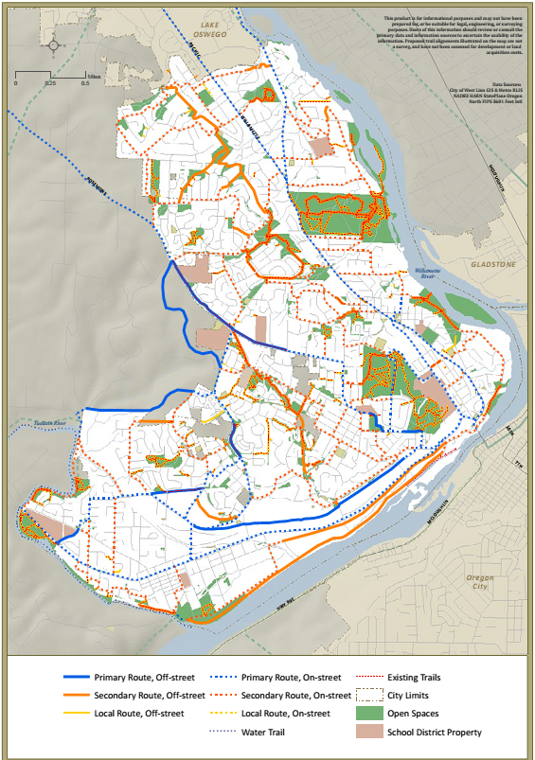

2014 City of West Linn Economic Opportunities Analysis (TBD)
This plan is currently under development with an anticipated completion date of spring 2015.

City of West Linn Arch Bridge Master Plan (TBD)
This plan is currently under development with an anticipated completion date of summer 2015.

City of West Linn Pavement Management Program Budget Options Report, June 2011
This report summarizes the current state of the City’s street network, the likely state of the street network over the next five years, and what steps can be taken to improve the overall condition of the City’s street network. In 2011, the overall pavement condition index (PCI) was 62 (on a scale of 0-100), down from 65 in 2009. At the current funding level, the citywide PCI is anticipated to be at 54 in 2016. As streets fall below a PCI of 50 (poor condition) they will require more extensive treatment – such as thick overlays and full reconstructions – that are more expensive than slurry seals and thin overlays that could be applied to roadways in better condition.
The report presents four budget scenarios, ranging from the current projected funding level – of $300,000 over the next five years – to $18.7 million over five years (the amount required to bring the street network into Good condition).
In 2013, the West Linn City Council voted to increase the City’s street maintenance fee on all residential users by 75 percent; with a 5 percent increase over the next four fiscal years. The City Council is currently considering whether to raise the street fee for non-residential users. (City of West Linn, 2011)

Metro Regional Transportation Plan Compliance

Metro 2014 Regional Transportation Plan (RTP) Update
Between 2010 and 2040, the region is expected to host nearly 1 million new residents. Where these people live and work and how they get around will have a significant impact on the livability of the region. Implicit in the 2040 Regional Growth Concept (the Regional Comprehensive Plan, which provides direction for the RTP) is the understanding that compact development is more sustainable, more livable and more fiscally responsible than low-density sprawl, and will help reduce the region’s carbon footprint. In coming decades, the region will also need to find ways to accommodate a population that is older, more culturally diverse and do so with declining state and federal revenues.

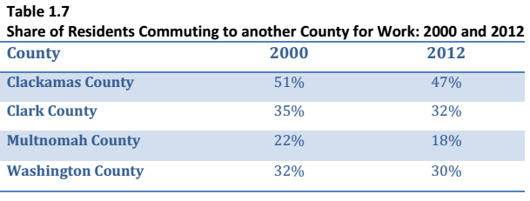
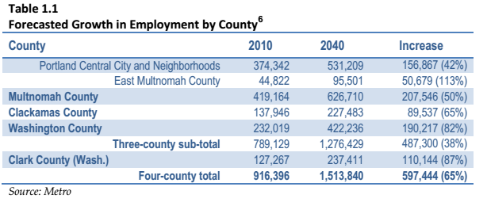

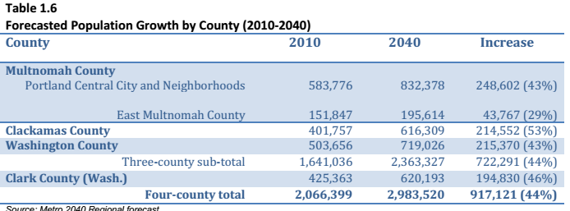
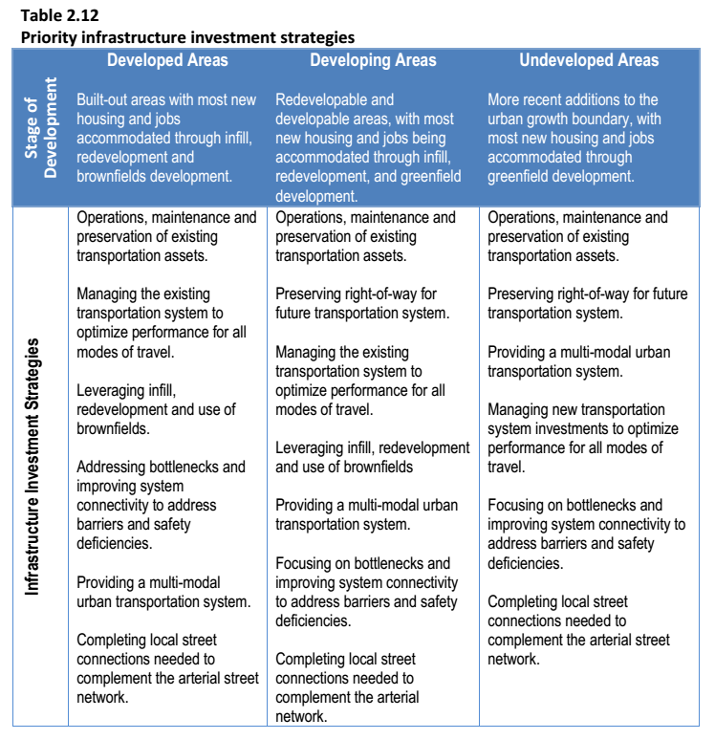
The 2014 RTP establishes the following priorities:
- Build a well-connected network of complete streets that prioritize safe and convenient pedestrian and bicycle access;
- Improve local and collector street connectivity
  - Local streets should be spaced no more than 530-feet in new residential and mixed-use areas;
  - Cul-de-sacs should be limited to 200-feet in length;
  - Encourage local traffic to use local and collector streets to minimize local travel on regional arterial streets.
- Maximize system operations by implementing management strategies prior to building new motor vehicle capacity, where appropriate.
- Transit:
  - Build the total network and transit supportive land uses to leverage investments. Provide frequent, reliable bus and rail service during all times of the day, every day of the week. Improve the environment where people walk to and from transit facilities. Emphasize walking and biking to transit and deemphasize driving to transit.
  - Expand high capacity transit:
    - Expand regional and local frequent service transit;
    - Improve local service transit;
    - Support expanded commuter rail and intercity transit service to neighboring communities;
    - Improve pedestrian and bicycle access to transit.
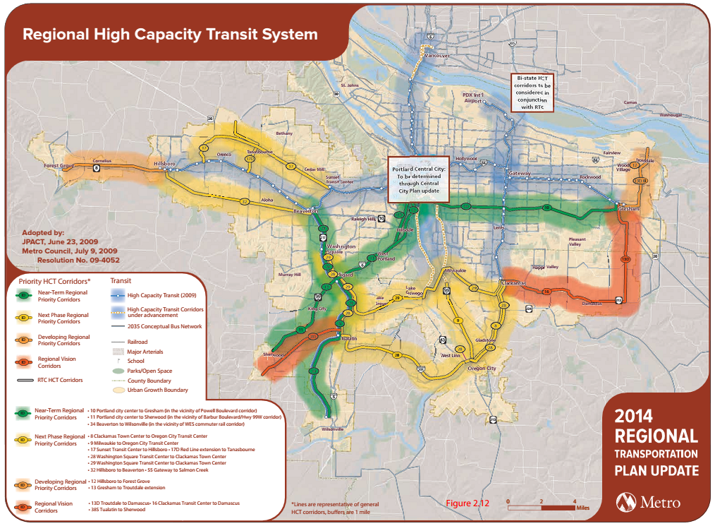
    - West Linn is adjacent to two “Next-phase Regional Priority Corridors” from the Metro Regional High Capacity Transit Plan. Project number 28 anticipates a connection between the Washington Square Transit Center and the Clackamas Town Center in the vicinity of I-205 and project number 9 is an extension of the nearly completed Milwaukie Light Rail Line that would extend some form of High Capacity transit service from Milwaukie to the Oregon City Transit Center via Highway 99E.

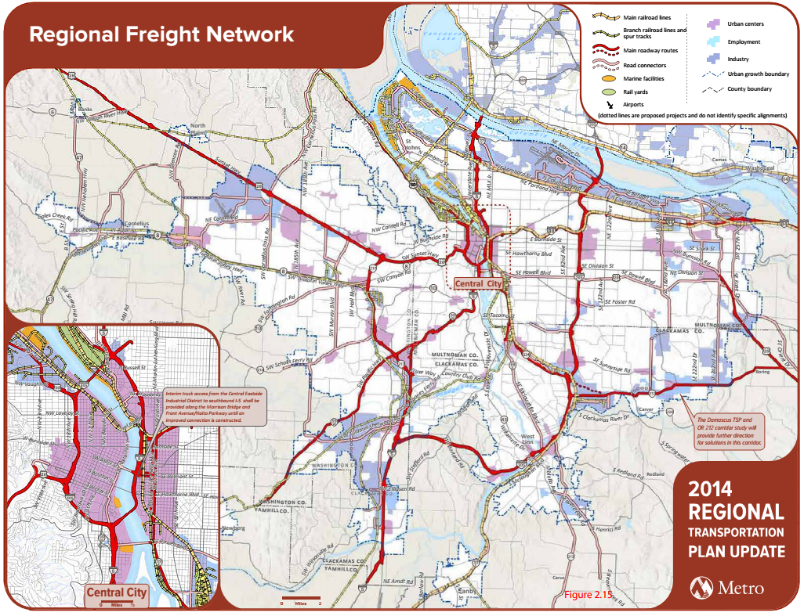
- Regional Freight: Population and employment growth in the Portland Metropolitan region (917,000 new residents and 587,000 new workers) between 2010 and 2040 is anticipated to contribute to an additional $730 billion in traded sector goods and will significantly increase the volume of local freight deliveries along regional and local freight routes. In addition, the Portland Metropolitan region has a higher than average dependency on traded sector industries; in particular, computer/electronic products, wholesale distribution services, metals, forestry, wood and paper. It is critical that the region prioritize improved freight system operations to reduce delay, increase freight reliability and provide cost-effective choices for shippers. I-205 serves as the sole freight route near West Linn.

- Active Transportation:
  - Biking
    - Make walking and biking the most convenient, safe and enjoyable transportation choices for short trips less than three miles (45 percent of all trips in the region are less than three miles and 15 percent are less than 1 mile);
    - Build an interconnected regional network of bicycle routes and districts integrated with transit and nature that prioritizes seamless, safe, convenient and comfortable access to urban centers and essential daily needs, including schools and jobs, for all ages and abilities;
    - Build a green ribbon of bicycle parkways as part of the region’s integrated mobility strategy (Highway 43, Salamo Rd., Stafford Rd., and Willamette Falls Drive are identified in the regional bicycle parkway network);
    - Improve bike-transit connections;
    - Ensure that the regional bicycle and pedestrian network equitably serves all people.
  - Pedestrians
    - Make walking and biking the most convenient, safe and enjoyable transportation choice for short trips less than three miles;
    - Build a well-connected network of pedestrian routes, including safe street crossings, integrated with transit and nature that prioritize seamless, safe, convenient and comfortable access to urban centers and essential daily needs, including schools and jobs, for all ages and abilities;
    - Create walkable downtowns, centers, main streets and station communities that prioritize safe, convenient and comfortable pedestrian access for all ages and abilities;
    - Improve pedestrian access to transit;
    - Ensure that the regional pedestrian network equitably serves all people.
  - Transportation System Management and Operations (TSMO)
    - Use advanced technologies, pricing strategies and other tools to actively manage the transportation system;
    - Provide comprehensive real-time traveler information to people and businesses;
    - Improve incident detection and clearance times on the region’s transit, arterial and throughway networks;
    - Implement incentives and programs to increase awareness of travel options.
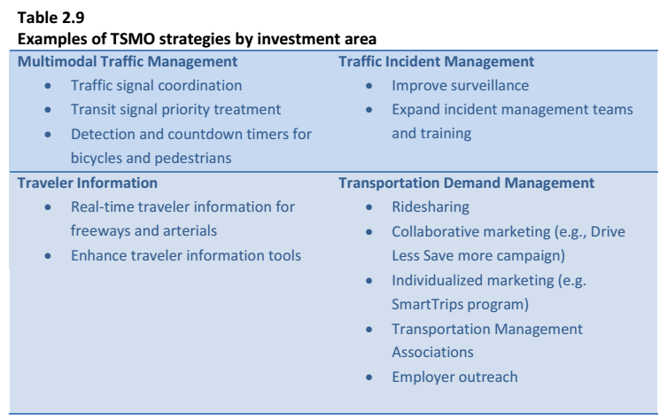

Metro 2035 Regional Transportation Functional Plan
The Regional Transportation Functional Plan implements the goals and policies established in the 2035 RTP (improved public health; safety and security for all; attraction of jobs and housing to downtowns, main streets, corridors and employment areas; creating vibrant, livable communities, sustaining the region’s economic competitiveness and prosperity; efficient management to maximize use of the existing transportation system; completion of the transportation system for all modes of travel to expand transportation choices; increasing use of the transit, pedestrian and bicycle systems; ensuring equity and affordable transportation choices; improving freight reliability; reducing vehicle miles traveled and resulting emissions; and promoting environmental and fiscal stewardship and accountability) and sets minimum standards for local governments to adopt as part of their local TSP development.
Local implementation of the RTP will result in a more comprehensive approach for implementing the 2040 Growth Concept, help communities achieve their aspirations for growth and support current and future efforts to achieve the principal objectives of the RTP and address climate change. If a TSP is consistent with the RTFP, Metro shall deem it consistent with the RTP. (Metro, 2010)

Metro Active Transportation Plan
The Active Transportation Plan (ATP) identifies a vision, policies and actions to complete a seamless network of on- and off-street pathways and districts connecting the region integrating walking, biking, and public transit. The ATP strives to make it easier for people to walk and ride a bike and access transit to get to work, school, to parks and other destinations by updating the pedestrian and bicycle policies in the 2014 Regional Transportation Plan. Key ATP objectives priorities include:
- Complete the active transportation network
- Make it safe to walk and ride a bicycle for transportation
- Ensure that the regional active transportation network equitably serves all people
- Support populations that are already driving less by making it easier to drive less
- Increase levels of funding dedicated to active transportation projects and programs and develop a pipeline of projects
- Better integrate and connect transit, walking and bicycle networks
- Make walking and bicycling the most convenient, safe and enjoyable choices for short trips less than three miles
- Utilize data and analyses to guide transportation investments
- Include bicycle and walking improvement in roadway preservation projects whenever possible to make all streets in the region complete streets
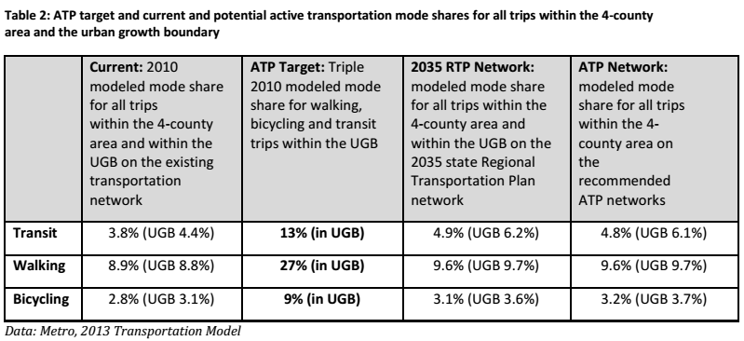
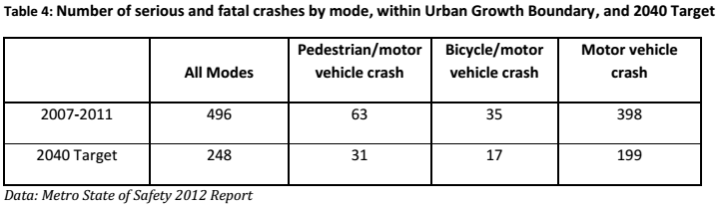

Coordination
Clackamas County Transportation System Plan
Through the statewide planning program’s TPR, the West Linn TSP update needs to be coordinated with the Clackamas County TSP. Consistency between the County TSP and City TSP is assumed if both plans are “consistent” with the RTP. Before explaining the RTP requirements that are applicable to both the City and County TSP, readers may be interested to know the direction the recently updated County TSP has taken to address what the County has identified as the most significant transportation-related challenges in coming decades:
- Limited funding that has not and will remain unable to keep pace with the mobility needs of the County.
- Reducing congestion. The County TSP recognizes the connection between land uses and transportation and the ability to decrease reliance on automobiles and reduce congestion through coordinated land use and transportation planning.
- Balancing the need for mobility (through movement of traffic) with the need for local movement and access to individual properties.
- Developing facilities that accommodate all travel modes will improve safety for users. The County TSP calls for a 50 percent reduction in fatal and serious injury crashes by 2022.
- Transportation infrastructure needs to be sensitive to the potential impacts to neighborhoods and to the natural environment in order to create and maintain livable communities, preserve air and water quality and conserve energy.
To address these challenges the county TSP includes the following policies and strategies – which may serve as a “window” for what West Linn wishes to address in the City’s TSP update to have plan “consistency”; however, the County’s TSP primarily applies to unincorporated areas.
- Compliance and coordination Support partnerships to promote and address multi-jurisdictional transportation needs:
- Road safety:
  - 50 percent reduction in fatal and serious injury crashes by 2022;
  - Address the top three crash cause factors of aggressive driving, young drivers (15-22) and roadway departure using education, emergency medical services, enforcement, engineering and evaluation;
  - Support actions that increase awareness and education about the safety of the transportation system for all users;
  - Support data-driven approaches to improve safety for all transportation users.
- Equity, health and sustainability:
  - Support projects, such as pedestrian and bike connections to transit stops, that expand and improve transportation options for residents in areas with identified transportation disadvantaged populations;
  - Minimize transportation-related environmental degradation;
  - Increase and improve infrastructure needed to support alternative fuel vehicles;
  - Support programs that educate people about opportunities for bicycle, pedestrian and transit options.
- Intelligent Transportation Systems (ITS): Implement a wide range of ITS strategies.
- Transportation Demand Management (TDM) policies:
  - Implement TDM to increase efficient use of existing transportation infrastructure and minimize congestion and safety concerns by offering choices of mode, route, and time;
  - Support efforts to monitor and fund regional TDM programs;
  - Provide adequate bike and pedestrian facilities to employment areas to encourage commute trips by walking and biking;
  - Support programs that identify safe bicycle and pedestrian routes to connect neighborhoods and schools;
  - 45-55 percent non-drive-alone target for regional centers, station communities and corridors;
  - 40-45 percent non-drive-alone target for employment areas, industrial areas, neighborhoods and regionally significant industrial areas.
- Integration of land use and transportation:
  - Support an integrated approach to land use and transportation planning that encourages livable and sustainable communities, decreases average trip length and increases accessibility for all modes;
  - Reduce reliance on long commutes out of the County to employment destinations;
  - Recognize the importance of moving goods from rural businesses to distribution centers.
- Active transportation:
  - Create an environment that encourages people to walk and bike for recreational and for transportation purposes;
  - Coordinate with pedestrian, bike and trail master plans, and with special transportation plans of the County;
  - Inform property owners of their responsibilities for the maintenance of sidewalks and pedestrian pathways;
  - Identify low traffic volume streets that are appropriate for signing as bike routes to enhance safety and connectivity and to supplement the system of bikeways found on the major street system.
- Facilities:
  - Encourage the provision of facilities and services for bicyclists, including showers, lockers, bike racks on buses, bike repair and maintenance, and secure bicycle parking;
  - Establish and maintain wayfinding systems to facilitate bicycle travel.
- Multi-use paths: Support the acquisition and development of multi-use paths on abandoned public and private rights-of-way.
- Functional classification and design:
  - Design arterials and collectors to allow safe and convenient passage of buses, bikes and pedestrians;
  - Streets, allays, bikeways, pedestrian facilities, multi-use paths, trails and transit stops are allowed uses in all urban zoning districts.
- Project Development:
  - Consider TDM before adding new capacity, including strategies such as; access management, alternative or modified standards, ITS, operational improvements, parking standards, enhanced bicycle and pedestrian facilities, traffic calming and road diets.
- Access Standards: New development and redevelopment should be designed to place driveway accesses on streets with the lowest functional classification or the lowest traffic volume.
- Policies on improvements to serve development: Require right-of-way (ROW) dedication, on-site frontage improvements, and off-site improvements as necessary to safely handle expected traffic generated by the development.
- Performance Evaluation Measures:
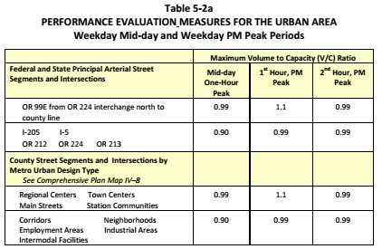
- Transit:
  - Identify existing transit deficiencies in the County, needed improvements, and additional park and ride lots necessary to increase the accessibility of transit services to all potential users;
  - Coordinate with transit agencies in all new residential, commercial and industrial developments to ensure integration of transit facilities and pedestrian access to transit facilities.
- Freight, rail, air, pipeline and water transportation:
  - Make freight investments that, in coordination with the County’s economic development strategies, help retain and grow the County’s job base and strengthen the County’s overall economy;
  - Support expansion and maintenance needed to establish reliable, higher speed (110-125 mph) freight rail service and intercity rail passenger service in the Willamette Valley;
  - Support the continued operation and maintenance of the Willamette Falls Locks to facilitate water transportation on the Willamette River.

- Finance and funding:
  - Identify and pursue new, permanent funding mechanisms to construct and maintain County transportation facilities and to support programs and projects identified in the TSP;
  - Develop dedicated funding sources to implement active transportation projects;
  - Establish funding for bicycle, pedestrian and transit projects that serve the needs of transportation disadvantaged populations.
- Special transportation projects: Work with ODOT, Metro, Oregon City, West Linn to analyze and develop a solution to the transportation bottleneck on I-205 between Oregon City and the I-205/Stafford Road interchange. (Clackamas County, 2014)

Emerging Regional Policy

Climate Smart Communities Scenarios Project
The Climate Smart Communities Scenarios Project (Climate Smart), directed by the Oregon Legislature, seeks to reduce greenhouse gas emissions for the Portland Metropolitan Area by 20 percent (per capita light vehicle emissions) below 2005 levels, by the year 2035. Findings from the Phase II report indicate that this target can be achieved; however, additional investment will be necessary. Phase II of the Climate Smart work has narrowed the focus to three scenarios that can achieve targeted levels of GHG emissions reduction. In 2014, representatives from the State and across the Portland Metropolitan area will decide specifically how this target will be achieved and will have to decide how much should be invested in public transit, how much reliance is placed on technology and information, how much of the active transportation network should be completed by 2035, how local communities should manage parking, and how we should pay for our choices, to name just a few. (Metro, 2014)

Service Provider Coordination

TriMet Transit Investment Plan
TriMet’s Transit Investment Plan guides future program and capital investment for the agency. The Plan calls for improving system safety and making transit use more convenient, reliable and easy to use. TriMet plans to continue to invest in high capacity transit services such as MAX light rail, commuter rail, bus rapid transit (BRT) and streetcar service within key regional corridors to connect regional centers. The Portland Streetcar Loop and South Corridor Phase 2 (Portland to Milwaukie) Light Rail Transit projects are examples of recently completed or nearly completed infrastructure investments that TriMet hopes will encourage greater use of the region’s public transit system.
High-capacity transit projects currently under development include the Southwest and Powell-Division Corridors. In addition, TriMet is working with regional partners to improve public transit service in regionally significant corridors, such as AmberGlen/Tanasbourne, Forest Grove, Gresham and Oregon City. The Transit Investment Plan also calls for the expansion of frequent transit service (bus lines that run every 15 minutes or better, every day) and improved local service. (TriMet, 2014) Although the Columbia River Crossing and Lake Oswego to Portland Transit projects are now off the table for regional discussion, there is regional interest for transit improvements in these areas as well.

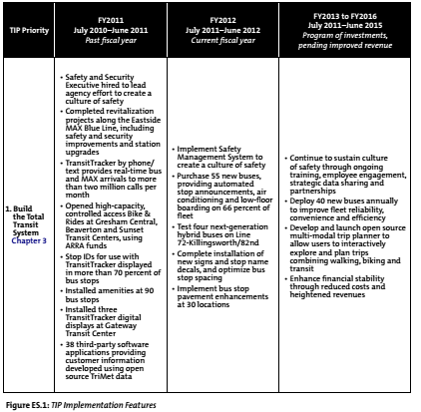
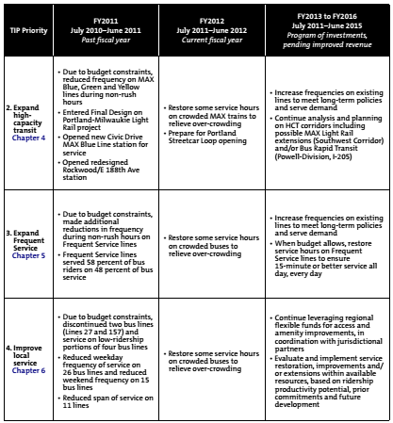

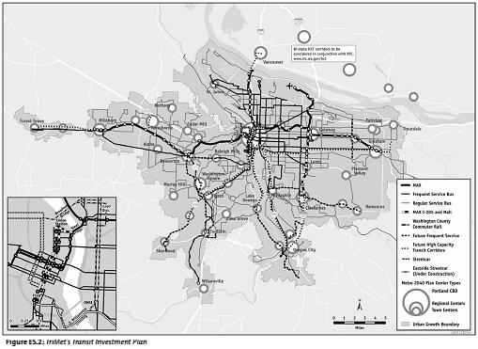

Coordinated Transportation Plan for the Elderly and People with Disabilities (TriMet 2012)
TriMet’s Coordinated Transportation Plan for the Elderly and People with Disabilities, “guides transportation investment toward a full range of options for elders and people with disabilities to foster independent and productive lives, to strengthen community connections, and strives for continual improvement of services through coordination, innovation and community involvement.” The key objectives of the Plan include:
- Coordinate. Make the best use of service hours and vehicles; assure that services are coordinated and well organized. Assure that customer information is useful and widely provided throughout the region.
- Innovate. Increase options available to E&D customers by providing innovative, flexible attractive and cost-effective alternatives to standard fixed route buses, rail and paratransit. Expand outreach and education on how to use services.
- Involve the Community. Include elders and people with disabilities, social services staff, private non-profit providers, and other community partners in the dialogue and decisions about services. Advisory committees working on E&D issues should have over 50 percent representation of elders and people with disabilities.
- Improve the service foundation. Fixed route service frequencies and coverage in some suburban areas, as well as ways to get to the fixed routes, will need to be improved.
- Integrate land use and transportation decisions. Communicate the importance of land use and transportation for E&D transportation. Identify opportunities to influence land use decisions and eliminate environmental barriers to using transit.
- Improve Customer Convenience. Minimize physical and psychological impediments to using core transit services relative to other modes. Make the transit system easy to understand and use. Facilitate transfers between transit services with the use of wayfinding information and high-amenity transfer facilities.
- Improve Safety. Assure that real and perceived safety concerns are addressed at passenger waiting areas and on board transit vehicles. Utilize transit provider staff, volunteers and other riders to increase sense of security along with investments in physical infrastructure where appropriate. (TriMet, 2012)

TriMet Pedestrian Network Analysis
In a survey conducted by Metro in 2013, 80 percent of respondents said they desired to live and work in areas where they could walk, bicycle and take public transit. TriMet recommends the following strategies for local TSPs:
- Word choice. Avoid calling walking, bicycling and public transit, “alternative modes of transportation.” Everyone uses at least one of these modes as part of every trip.
- The quality of pedestrian, bicycle facility and transit service matters. To encourage more trips by walking, bicycling and public transit, go beyond minimum design standards for walking and bicycling facilities, and focus development and investments in key corridors where you want to see more frequent transit service, bicycling and pedestrian trips.
- Analysis. Collect data that help identify meaningful and complete pedestrian, bicycle and transit needs.
- Prioritize specific locations and areas where people walk, bicycle and take public transit. Develop a list of pedestrian and bicycle projects, based on where it is most important for more people to be able to access specific places by walking, cycling or transit. It is most cost-effective and efficient to make improvements where they are most needed and most effective at achieving policy goals.
- Match ability and responsibility. Plans should be transparent and identify the responsible party. Plans should also identify, at the concept level, what steps are necessary to implement the plans.
- Tie City’s transit vision to actions, programs, and investments needed to make it feasible. When transit needs are stated in a TSP, include what is needed to support this type of service, e.g., proximity of X number of households and/or Y number of jobs to transit stops, streetscape and sidewalk investments, managed parking, etc. Include operating and capital costs associated with the type of service desired, so desires are tied to costs, especially if it isn’t directly in the City’s control.
- Unbundle pedestrian and cycling needs from larger road projects. Pedestrian or bicycle improvements made now deliver substantial benefits immediately, even if long-term future plans may include roadway widening that could require rebuilding some of the improvements. Stand-alone pedestrian and bicycling projects are cost-effective and provide substantial benefits in the near term.
- Strongly encourage broad participation. Invite a broad base of representative to help shape the plan. Ensure there is representation from communities of color and people of all income levels.
- Conduct field visits and safety audits of select corridors on foot and bicycle. Computer modeling and GIS analysis do not give a full understanding of the needs of pedestrians and bicyclists of all ages and abilities. (TriMet, 2011)

State Plans
The Statewide Planning Goals define the State’s planning objectives and priorities. The update of the City of West Linn’s TSP will amend the City’s comprehensive plan. As a part of the City comprehensive plan amendment, the TSP adoption will include a compliance report that explains how the TSP update complies with applicable state policies outlined below.

Oregon Statewide Planning Goals
- Goal 1 Citizen Involvement
- Goal 2 Land Use Planning
- Goal 5 Natural Resources, Scenic and Historic Areas, and Open Spaces
- Goal 6 Air, Water and Land Resources Quality
- Goal 7 Areas Subject to Natural Hazards
- Goal 9 Economic Development
- Goal 11 Public Facilities and Services
- Goal 12 Transportation – Administered through OAR 660, Division 12
- Goal 13 Energy Conservation
- Goal 14 Urbanization
- Goal 15 Willamette River

Oregon Transportation Planning Rule (OAR Chapter 660, Division 12)
The Transportation Planning Rule (TPR) is the administrative rule that implements Goal 12, Transportation. Its purpose is to facilitate coordination between land use and transportation planning in order to provide a safe, convenient and economic transportation system. The TPR is the rule that requires the development of state, regional and local TSPs. The TPR also includes provisions that require certain land use decisions to take into account the impact of development on the existing and/or planned capacity of the transportation system. Transportation System Plans define the planned system.
The TPR encourages coordination between the type and location of various land uses and transportation planning for the purpose of promoting travel patterns that minimize air pollution and traffic congestion. To do this, the TPR emphasizes measures that increase transportation choices and which make more efficient use of existing transportation infrastructure. Coordinated land use and transportation planning is intended to improve livability and accessibility through the provision of transit service, where feasible, and by improving the performance of existing infrastructure (i.e., transportation system management and demand management).
The TPR strives to reduce the reliance on single occupant vehicle (SOV) trips through more effective planning for non-SOV modes, and through improved street connectivity. The TPR also encourages land use patterns in urban areas that make it more convenient for people to walk, bike and take public transit, as well as to use automobiles more efficiently.
In metropolitan areas, the TPR requires that TSPs be designed to achieve adopted standards for increasing transportation choices and reducing automobile reliance. The TPR anticipates that metropolitan areas will reduce automobile reliance by changing land use patterns and transportation choice so that walking, bicycling and public transit are convenient and that people will be likely to drive less than they do today. (State of Oregon, DLCD, 2014)

The Oregon Transportation Plan (OTP) is the state’s TSP and overarching policy document along with the modal plans shown below that “nest” under it. The OTP is adopted by the Oregon Transportation Commission and similar in content to regional and local TSPs but differs in that it addresses the statewide transportation system and needs. The OTP takes into account the regional and local transportation needs for roadways, airports, marine ports, intermodal facilities, rail, bicycle and pedestrian facilities for a 20-year period and includes a financial forecast.

Oregon Transportation Plan

Sets policies, standards and targets for highway safety, accessibility and mobility that are in part reflected in the RTP, RTFP and Clackamas County TSP.
Oregon Highway Plan

Oregon Aviation Plan
Addresses public and private airports.

Addresses railways.
Oregon Rail Plan

Currently being updated.
Oregon Bike and Pedestrian Plan

New plan under development.
Oregon Transportation Options Plan

Sets policies standards and targets for public transit.
Oregon Transit Plan

Oregon Freight Plan
Sets policies standards and targets for Statewide Freight Movement.

A chief purpose of the Oregon Transportation Plan is to provide a policy framework for the development of a safe, efficient and sustainable transportation system that improves the State’s quality of life and economic vitality (Oregon Department of Transportation, 2006). The OTP is built around seven goals that all apply across the state and including to regional and local plans. The goal topics are listed below and the full goal text is shown in Appendix C.
- Mobility and Accessibility
- Management of the System
- Economic Vitality
- Sustainability
- Safety and Security
- Funding the Transportation System
- Coordination, Communication and Cooperation

The OTP identifies the following key initiatives necessary for its implementation. These same initiatives apply and are further refined in the Metro’s RTP and specifically, the RTFP.

- Maintaining and maximizing assets;
- Optimizing the performance of the existing system through technology;
- Integrating transportation, land use, economic development and the environment;
- Integrating the transportation system across jurisdictions and modes;
- Creating sustainable funding;
- Investing in strategic capacity enhancements.
Oregon Highway Plan

The 1999 Oregon Highway Plan (OHP) establishes policies and investment priorities for the State’s highway system over a 20-year planning horizon. The OHP strives to maintain and improve safe and efficient movement of people and goods, while supporting statewide, regional, and local economic growth and livability. The OHP is implemented through a number of policies and actions that guide management and investment decisions by defining a classification system for state highways, setting standards for mobility, employing access management techniques, supporting intermodal connections, encouraging public and private partnerships, addressing the relationship between the highway and land developments, and recognizing the responsibility to maintain and enhance environmental and scenic resources.
The following OHP policies are relevant to transportation planning in West Linn are shown in Appendix B.

Oregon Bike and Pedestrian Plan

The current working vision of the Oregon Bike and Pedestrian Plan states, “In Oregon, people of all ages, incomes, and abilities can get where they want to go on safe, well-connected biking and walking routes. People can access destinations in urban and rural areas and enjoy Oregon’s scenic beauty by walking and biking on a transportation system that respects the needs of its users and their sense of safety. Bicycle and pedestrian networks are recognized as integral elements of the transportation system that contribute to our diverse and vibrant communities and the health and quality of life enjoyed by Oregonians.”
The plan currently includes nine goals under development:
Safety: Eliminate bicycle and pedestrian fatalities and serious injuries and improve the sense of safety of those who bike and walk.
Mobility and Efficiency: Provide high quality biking and walking options for short and moderate distance trips as a means to improve mobility and efficiency of the transportation system.
Accessibility and Connectivity: Provide a complete bicycle and walking network that reliably and easily connects to destinations and other transportation modes.
Community and Economic Vitality: Improve people’s ability to access jobs, businesses, and other destinations.
Equity: Provide opportunities and choices for people of all ages, abilities, and incomes in urban, suburban, and rural areas across the state to bike or use walking routes to reach their destinations and to access transportation options.
Health: Provide Oregonians with the opportunity to become more active and healthy by using biking and walking to meet their daily needs.
Sustainability: Help to meet federal, state and local sustainability and environmental goals by providing zero emission transportation options like biking and walking.
Strategic Investment: Recognize Oregon’s strategic investments in biking and walking as important comonents of the transportation system that can help reduce the need for expanding motory ehicle capacity and reduce system costs.
Coordination, Cooperation and Collaboration: Work actively and collaboratively with federal, state, regional, local and private partners to provide consistent and seamless biking and walking networks that are integral to the transportation system.

APPENDIX A: Statewide Planning Goals

- Goal 1 Citizen Involvement – develop a citizen involvement program that insures the opportunity for citizens to be involved in all phases of the planning process
  - Cities shall develop a citizen involvement program, for land use planning efforts, that includes the following components:
    - Provide widespread citizen involvement
    - Assure effective two-way communication with citizens
    - Provide an opportunity for citizens to be involved in all phases of the planning process
    - Assure technical information is available in an understandable form
    - Assure that citizens will receive a response from policy-makers
    - Insure funding for the citizen involvement program
- Goal 2 Land Use Planning – establish a land use planning process and policy framework as a basis for all decisions and actions related to the use of land and to assure an adequate factual base for such decisions and actions.
- Goal 5 Natural Resources, Scenic and Historic Areas, and Open Spaces – protect natural resources and conserve scenic and historic areas and open spaces.
- Goal 6 Air, Water and Land Resources Quality – maintain and improve the quality of the air, water and land resources of the state.
- Goal 7 Areas Subject to Natural Hazards – protect people and property from natural hazards.
- Goal 8 Recreational Needs – to satisfy the recreational needs of the citizens of the state and visitors and, where appropriate, to provide for the siting of necessary recreational facilities including destination resorts.
- Goal 9 Economic Development – provide adequate opportunities throughout the state for a variety of economic activities vital to the health, welfare, and prosperity of Oregon’s citizens. Comprehensive plans and policies shall contribute to a stable and healthy economy in all regions of the state.
- Goal 10 Housing – provide for the housing needs of citizens of the State. Plans shall encourage the availability of adequate numbers of needed housing units at price ranges and rent levels which are commensurate with the financial capabilities of Oregon households and allow for flexibility of housing location, type and density. “Needed housing units” means: housing types determined to meet the need shown for housing within an urban growth boundary at particular price ranges and rent levels. Needed housing units also includes government-assistance housing. For cities having populations larger than 2,400 people, needed housing units include (but are not limited to) attached and detached single-family housing, multiple-family housing, and manufactured homes, whether occupied by owners or renters.
- Goal 11 Public Facilities and Services – plan and develop a timely, orderly and efficient arrangement of public facilities and services to serve as a framework for urban and rural development.
- Goal 12 Transportation – provide and encourage a safe, convenient and economic transportation system. A transportation plan shall:
  - Consider all modes of transportation including mass transit, air water, pipeline, rail, highway, bicycle and pedestrian
  - Be based upon an inventory of local, regional and state transportation needs
  - Consider the differences in social consequences that would result from utilizing differing combinations of transportation modes
  - Avoid principal reliance upon any one mode of transportation
  - Minimize adverse social, economic and environmental impacts and costs
  - Conserve energy
  - Meet the needs of the transportation disadvantaged by improving transportation services
  - Facilitate the flow of goods and services to strengthen the local and regional economy
  - Conform with local and regional comprehensive land use plans
  - Transportation system should be planned to use existing facilities and rights-of-way within the state provided that such use is not inconsistent with the environmental, energy, land use economic or social policies of the state
  - Population densities and peak house travel patterns of existing and planned development should be considered in the choice of transportation modes for trips taken by persons. While high density developments with concentrated trip origins and destinations should be designed to be principally served by mass transit, low density developments with dispersed origins and destinations should be principally served by the auto.
- Goal 13 Energy Conservation – to conserve energy. Land and uses developed on the land shall be managed and controlled so as to maximize the conservation of all forms of energy, based upon sound economic principles:
  - Priority in land use planning should be given to methods of analysis and implementation measures that will assure maximum efficiency in energy utilization.
  - Land uses should minimize the depletion of non-renewable sources of energy.
  - Land use planning should seek to recycle and re-use vacant land and those uses which are not energy efficient.
  - Land use planning should, to the maximum extent possible, combine increasing density gradients along high capacity transportation corridors to achieve greater energy efficiency.
- Goal 14 Urbanization – provide an orderly and efficient transition from rural to urban land use, accommodate urban population and urban employment inside urban growth boundaries, ensure efficient use of land, and provide livable communities. Land within urban growth boundaries shall be considered available for urban development consistent with plans for the provision of urban facilities and services. Comprehensive Plans and implementing measures shall manage the use and division of urbanizable land to maintain its potential for planned urban development until appropriate public facilities and services are available or planned.
- Goal 15 Willamette River Greenway – protect, conserve, enhance and maintain the natural, scenic, historic, agricultural, economic and recreational qualities of lands along the Willamette River as the Willamette River Greenway. (State of Oregon, DLCD, 2014)

APPENDIX B: Oregon Highway Plan

      - Policy 1A – State Highway Classification System
Interstate 205 (I-205) and Oregon Highway 43 (Hwy 43) are classified as state highways. I-205 is further sub-classified as an interstate highway, whose function is to provide connections to major cities and other states. Interstates are major freight routes with the objective of providing mobility. The key management objective for interstate highways is to provide safe and efficient high-speed continuous-flow operation in urban and rural areas.
Hwy 43 is sub-classified as a district highway and is intended to function as a regional arterial roadway. District highways provide connections between small urbanized areas, rural centers and urban hubs, while also serving local access traffic. The key management objective for district highways in an urban setting is to provide for safe and efficient, moderate to low-speed operation for traffic flow and for pedestrian and bicycle movements.
      - Policy 1B – Land Use and Transportation. Recognizes that land development and transportation networks greatly influence one another. Compact land development patterns that reduce dependence on the state highway system for local trips. This policy also recognizes the positive and negative impacts of state highways on a local economy and establishes a framework for developing solutions to local development in or near state highway interchanges.
      - Policy 1C – State Highway Freight System
This policy seeks to ensure that freight is able to move efficiently on the State’s major trucking routes. The Freight policy balances the need to move goods with other uses of the highway system and recognizes the importance of maintaining efficient through movement on major truck and freight routes, such as I-205.
      - Policy 1F – Highway Mobility Standards
The OHP understands the unique context and policy choices (regional plan that prescribes minimum densities, mixed-use development and transportation options; primary reliance on high-capacity transit to provide additional capacity in the freeway corridors serving the central city; an air quality attainment/maintenance plan that relies heavily on reducing auto trips through land use) that have been made by cities in the Portland Metropolitan Region and has therefore established a process for alternate mobility standards.
Cities and counties in the Portland Metropolitan Area (metro area) may adopt alternate mobility standards where it is clear that reduced mobility will lead to congestion that will not be alleviated by highway improvements. Alternative standards shall be clear and objective and shall be related to the ratio of volume to capacity (v/c) or another similar metric (e.g., corridor-average v/c, network-average v/c, and the ratio of average daily traffic and hour capacity (adt/c)). These standards are adopted as part of the regional transportation plan where it has been demonstrated that it is infeasible to meet the adopted highway mobility standards below:

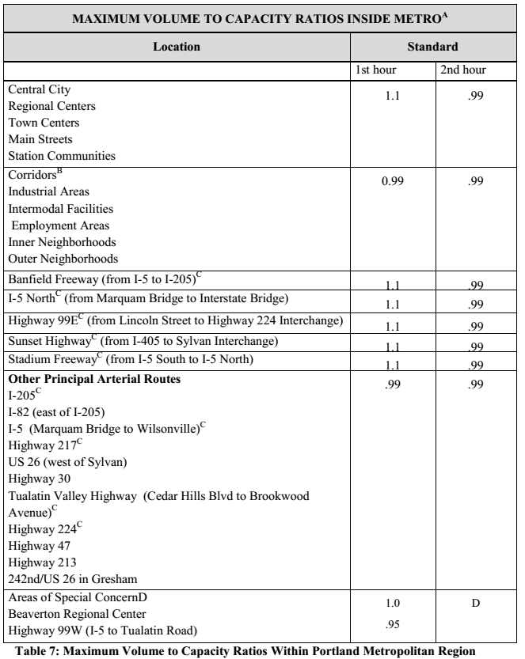
Notes for Table 7: Maximum volume to capacity ratios for two hour peak operating Conditions through a 20-year horizon for state highway sections within the Portland Metropolitan area urban growth boundary. A) The volume to capacity ratios in the table are for the highest two consecutive hours of weekday Traffic volumes. This is calculated by dividing the traffic volume for the average weekly two-hour PM peak by twice the hourly capacity. B) Corridors that are also state highways are 99W, Sandy Boulevard, Powell Boulevard, 82nd Avenue, North Portland Road, North Denver Street, Lombard Street, Hall Boulevard, Farmington Road, Canyon Road, Beaverton-Hillsdale Highway, Tualatin Valley Highway (from Hall Boulevard to Cedar Hills Boulevard and from Brookwood Street to E Street in Forest Grove), Scholls Ferry Road, 99E (from Milwaukie to Oregon City and Highway 43. C) Thresholds shown are for interim purposes only; refinement plans for these corridors are Required in Metro’s Regional Transportation Plan and will include a recommended motor Vehicle performance policy for each corridor. D) Areas with this designation are planned for mixed use development, but are also characterized by physical, environmental or other constraints that limit the range of acceptable transportation solutions for addressing a level-of-service need, but where alternative routes for regional through traffic are provided. In these areas, substitute performance measures are allowed by OAR.660.012.0060(2)(d). Provisions for determining the alternative performance measures are included in Section 6.7.7 of the 2000 RTP. The OHP mobility standard for state highways in these areas applies until the alternative performance measures are adopted in local plans and approved by the Oregon Transportation Commission.

      - Policy 1G – Major Improvements
This policy establishes that the State will prioritize the maintenance of highway performance, improved safety and improved system efficiency before adding new capacity.
      - Policy 2A – Partnerships
Establish cooperative partnerships to make more efficient and effective use of limited resources in the development, operation and maintenance of the highway system. Consult with local and regional governments regarding the potential for local participation on major modernization projects considered for inclusion in the STIP. When major improvements to or replacement of an interchange are necessary, work in partnership with local and regional government regarding financial participation, right-of-way contributions, and other enhancements.
      - Policy 2B – Off-system Improvements
Provide State financial assistance to local jurisdictions to develop, enhance and maintain improvements on local transportation systems when they are a cost effective way to improve the operation of the state highway system if:
        - Benefits to the state system are greater than those that would be achieved by investing in system improvements;
        - Local jurisdictions adopt land use, access management and other policies and ordinances that assure the continued benefit of the off-system improvement to the state highway system;
  - Local jurisdictions provide advanced notice to ODOT of land use decisions that may impact the off-system improvement in such a way as to adversely impact the state highway system;
  - Local jurisdictions agree to a minimum maintenance level for the off-system improvement that will assure the continued benefit of the off-system improvement to the state highway system.
      - Policy 2C – Interjurisdictional Transfers
In cooperation with local jurisdictions, consider transfers that: simplify the management responsibilities of a roadway segment; reflect the appropriate functional classification of a particular roadway segment; lead to increased efficiencies in the operation and maintenance of a roadway segment or corridor.
      - Policy 2E – Intelligent Transportation Systems
Work with small cities to develop a toolbox of ITS applications that emphasize safety enhancements, traveler information, incident response, and congestion relief. Support ITS planning, development, and implementation in local TSPs.
      - Policy 2F – Traffic Safety
Establish a process to develop and implement the most cost-effective solutions to high priority safety problems. Traffic safety solutions may include: better traffic enforcement; educational materials and signage to change driving behavior; engineering improvements; constructing safe and convenient pedestrian and bicycle crossings; and, managing access to the state highway. The OHP encourages local governments to adopt a safety management system and to work with citizens to address safety concerns on the state highway system.
      - Policy 3A – Classification and Spacing Standards
The OHP provides flexibility in access spacing standards to local governments seeking to promote development along state highways through the use of Urban Business Areas (UBAs) and Special Transportation Areas (STAs).
      - Policy 3B – Medians
Manage and locate medians in a manner that enhances the efficiency and safety of the highways and that influence and support land use development patterns that are consistent with approved TSPs.
      - Policy 3C – Interchange Access Management Areas
Interchange Access Management Plans (IAMPs) are necessary to protect the function of interchanges and to provide safe and efficient operations between connecting roadways. Local comprehensive plans should identify improvements such as, channelization, medians and access control in interchange areas as well as sources of funding to ensure these areas provide the functionality necessary to support the state and local roadway system. The design of urban interchange areas must consider the need for transit and park and ride facilities and the impact of the interchange on pedestrian and bicycle traffic.
      - Policy 4A – Efficiency of Freight Movement
Balance the needs of long distance and through freight movements with local transportation needs on highway facilities in urban areas.
      - Policy 4B – Alternative Passenger Modes
The OHP encourages alternative passenger transportation systems where travel demand, land use and other factors indicate the potential for their successful development as a means to help or maintain established performance standards.

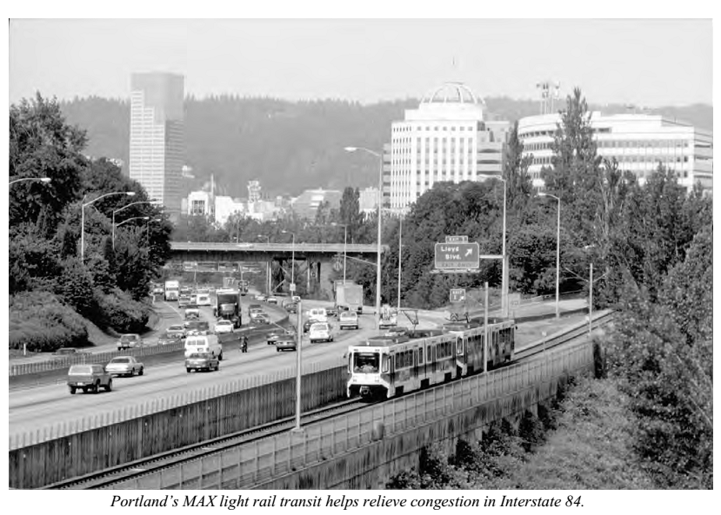
Alternative passenger transportation service should be incorporated as one part of a larger corridor strategy that may include developing land use regulations that support high capacity transit and developing adequate collector-distributor roadway systems. This policy suggests the following additional measures:
        - Encourage the use of alternative passenger modes to reduce local trips on the state highway system where limited highway facilities accommodate large numbers of intercity and local trips;
        - Support the development of alternative intercity passenger services in congested transportation corridors through additional peak hour service, use of excess freight rail system capacity, and the provision of support facilities and services which help connect passengers to their destinations;
      - Policy 4C – High-occupancy Vehicle Facilities
Utilize HOV facilities to improve the efficiency of the highway system in locations where travel demand, land use, transit, and other factors are favorable to their effectiveness. HOV facilities should be promoted in corridors where they are supported in local or regional TSPs, where current or projected demand will allow for efficient operations and where HOV facilities will function as part of the overall transportation system. This policy also encourages the use of HOV support facilities such as park and ride lots and preferential HOV parking.
      - Policy 4D – Transportation Demand Management
Support the efficient use of the transportation system through investment in TDM strategies. Support strategies that reduce single-occupant vehicle travel during the peak commute periods and that improve the traffic flow on the state highway system.
      - Policy 4E – Park and Ride Facilities
Seek cost effective expansion of the capacity of the state highway system through the development of park and ride facilities at appropriate urban locations. The OHP recommends using surplus ODOT property for park and ride facilities where appropriate and providing park and ride facilities in urban areas that are safely accessible by pedestrians, bicyclists, and transit users when feasible.
      - Policy 5A – Environmental Resources
Maintain or improve the natural and built environment including air quality, fish passage and habitat, wildlife habitat and migration routes, sensitive habitats, vegetation, and water resources where affected by ODOT facilities. Additional guidance includes:
        - Use best management practices to minimize effects of construction, operations and maintenance impacts to the human and natural environment;
        - Attain and maintain air quality standards in highway plans, programs, projects and maintenance activities and ensure that air quality plans are implemented and budget money for these purposes as available. (Oregon Department of Transportation, 2014)

Oregon Access Management Rule (OAR 734-051-0155)
The Oregon Access Management Rule mimics much of the direction established in the Oregon Highway Plan and the Oregon Transportation Plan in its preference toward maintaining and improving highway performance and safety through improved system efficiency, prior to adding new capacity. This policy also directs the state to work with local agencies in developing interchange management plans where new or significant modifications to existing interchanges are desired. (Oregon Department of Transportation, 2014)

APPENDIX C: Oregon Transportation Plan Goals

Each Oregon Transportation Plan goal listed below has a set of related policies that can be seen at the following link under “Oregon Transportation Plan, Volume 1”: http://www.oregon.gov/ODOT/TD/TP/Pages/OTP.aspx

- Mobility and Accessibility: “Provide a balanced, efficient and integrated transportation system that ensures interconnected access to all areas of the state, the nation and the world. Promote transportation choices that are reliable, accessible and cost-effective.”
- Management of the System: “Improve the efficiency of the transportation system by optimizing operations and management. Manage transportation assets to extend their life and reduce maintenance costs.”
- Economic Vitality: “Expand and diversify Oregon’s economy by transporting people, goods, services and information in safe, energy-efficient and environmentally sound ways. Provide Oregon with a competitive advantage by promoting an integrated freight system.”
- Sustainability: “Meet present needs without compromising the ability of future generations to meet their daily needs from the joint perspective of the environment, economy and communities. Encourage conservation and communities that integrate land use and transportation choices.”
- Safety and Security: “Build, operate and maintain the transportation system so that it is safe and secure. Take into account the needs of all users: operators, passengers, pedestrians and property owners.”
- Funding the Transportation System: “Create sources of revenue that will support a viable transportation system today and in the future. Expand ways to fund the system that are fair and fiscally responsible.”
Coordination, Communication and Cooperation: “Foster coordination, communication and cooperation between transportation users and providers so various means of transportation function as an integrated system. Work to help all parties align interests, remove barriers and offer innovative, equitable solutions.”
The OTP identifies the following key initiatives necessary for its implementation:
- Maintaining and maximizing assets;
- Optimizing the performance of the existing system through technology;
- Integrating transportation, land use, economic development and the environment;
- Integrating the transportation system across jurisdictions and modes;
- Creating sustainable funding;
- Investing in strategic capacity enhancements.

Works Cited
City of West Linn. (2008, December). Comprehensive Plan and Neighborhood Plans. Retrieved June 11, 2014, from City of West Linn: http://westlinnoregon.gov/sites/default/files/fileattachments/planning/page/6526/web20version20revised20april20200920with20maps.pdf
City of West Linn. (2008, December). Transportation System Plan. Retrieved June 11, 2014, from City of West Linn: http://westlinnoregon.gov/sites/default/files/fileattachments/public_works/page/5402/post_1_transportation_system_plan_2008.pdf
City of West Linn. (2011, June). Pavement Management Report. Retrieved June 11, 2014, from City of West Linn: http://westlinnoregon.gov/publicworks/pavement-management-report
City of West Linn. (2013). City-wide Trails Master Plan. Retrieved June 11, 2014, from City of West Linn: http://westlinnoregon.gov/planning/city-wide-trails-master-plan
City of West Linn. (2014). Capital Improvement Plan. Retrieved June 11, 2014, from City of West Linn: http://westlinnoregon.gov/sites/default/files/fileattachments/finance/page/7208/cip_reduced_file_size_0.pdf
Clackamas County. (2014, June 11). Comprehensive Plan. Retrieved June 11, 2014, from Clackamas County: http://www.clackamas.us/planning/documents/compplan/Chapter%205%20Transportation.pdf
Metro. (2010, September 8). Metro Regional Transportation Plan. Retrieved June 11, 2014, from Metro: http://library.oregonmetro.gov/files//appendix_23_rtfp.pdf
Metro. (2014). Climate Smart Communities Scenarios Project. Retrieved June 11, 2014 , from Metro: http://www.oregonmetro.gov/public-projects/climate-smart-communities-scenarios/project-library
Oregon Department of Transportation . (2014, June 11). Oregon Bicycle and Pedestrian Design Guidelines. Retrieved June 11, 2014, from Bicycle and Pedestrian Program: http://www.oregon.gov/ODOT/HWY/BIKEPED/Pages/planproc.aspx
Oregon Department of Transportation. (2006). Oregon Transportation Plan. Salem, OR 97301: Oregon Department of Transportation.
Oregon Department of Transportation. (2014, June 11). Administrative Rules. Retrieved June 11, 2014, from ODOT Access Management: http://www.oregon.gov/ODOT/HWY/ACCESSMGT/pages/technicalbulletins.aspx
Oregon Department of Transportation. (2014, June 11). Oregon Highway Plan. Retrieved June 11, 2014, from Transportation Development - Planning: http://www.oregon.gov/ODOT/TD/TP/pages/ohp.aspx
State of Oregon, DLCD. (2014, June 11). Statewide Planning Goals. Retrieved June 11, 2014, from Oregon Department of Land Conservation and Development: http://www.oregon.gov/LCD/pages/goals.aspx
State of Oregon, DLCD. (2014, June 11). Transportation Planning Rule. Retrieved June 11, 2014, from Oregon Department of Land Conservation and Development: http://www.oregon.gov/LCD/pages/rulemaking_tpr_2011.aspx
TriMet. (2011, September). Pedestrian Network Analysis Project. Retrieved June 11, 2014, from TriMet: http://trimet.org/projects/pedestrian-network.htm
TriMet. (2012, October). Coordinated Transportation Plan for Elderly and Persons with Disabilities. Retrieved June 11, 2014, from TriMet: http://trimet.org/pdfs/publications/elderly-and-disabled-plan.pdf
TriMet. (2014, June 11). TriMet Transit Investment Plan. Retrieved June 11, 2014, from TriMet: http://trimet.org/pdfs/tip/tip.pdf

Adopted February 1994 and updated September 2008.
Consistent with Oregon Transportation Plan, Goal 7, Coordination, Communication and Cooperation
Unique to Clackamas County TSP.
Consistent with Oregon Transportation Plan, Goal 4, Sustainability.
Consistent with Portland Metro RTP, Policy 2.5.7 Transportation System Management and Operations (TSMO) Vision, (pg. 2-74) http://www.oregonmetro.gov/sites/default/files/2035_rtp_final_document_as_submitted_and_approved_by_dlcd_usdot_web_0.pdf
TSP are required to have “localized TDM” as set forth by the Regional Transportation Functional Plan (RTFP) Title 2, Section 3.08.220. The non-drive alone targets shown under the sub-bullets above are set forth by the same section of Title 2 as achieved in part through the integration of land use and transportation and active transportation.

