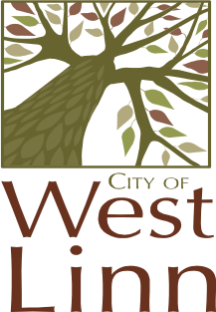
CITY OF WEST LINN
LAND USE PRE-APP CONFERENCE MEETINGS
THURSDAY, JULY 17
CITY HALL
22500 SALAMO RD
WILLAMETTE CONFERENCE ROOM

9:00 a.m. 6-Lot PUD
19650 Suncrest Drive
Handris Properties-Steve Oaks
(Hidden Springs Neighborhood Assoc.)
PA-08-20 Planner: Tom Soppe

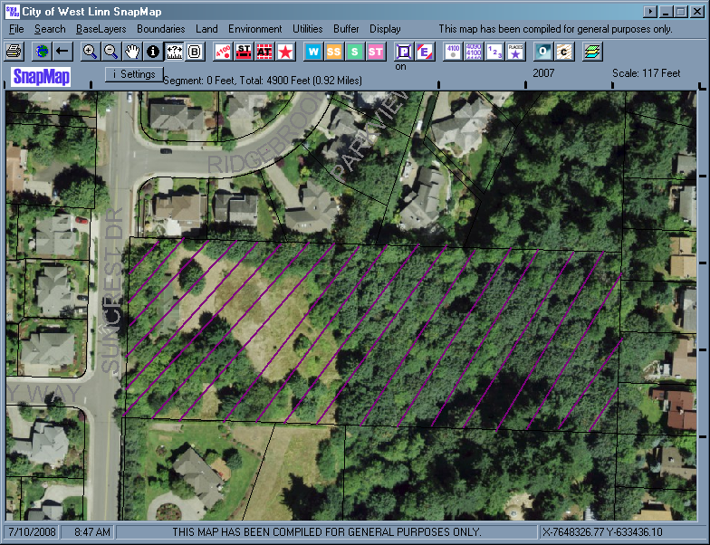
Office Use Only:
Pre-application Referal Response Due By : July 14, 2008 or bring to conference meeting.

