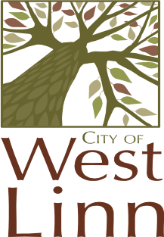
CITY OF WEST LINN
LAND USE PRE-APP CONFERENCE MEETINGS
THURSDAY, JULY 17
CITY HALL
22500 SALAMO RD
WILLAMETTE CONFERENCE ROOM

8:00 a.m. Replacement Deck in Natural Drainage Way Area
17887 Hillside Drive
Karen & Robert Chadwick
(Robinwood Neighborhood Assoc.)
PA-08-24 Planner: Tom Soppe

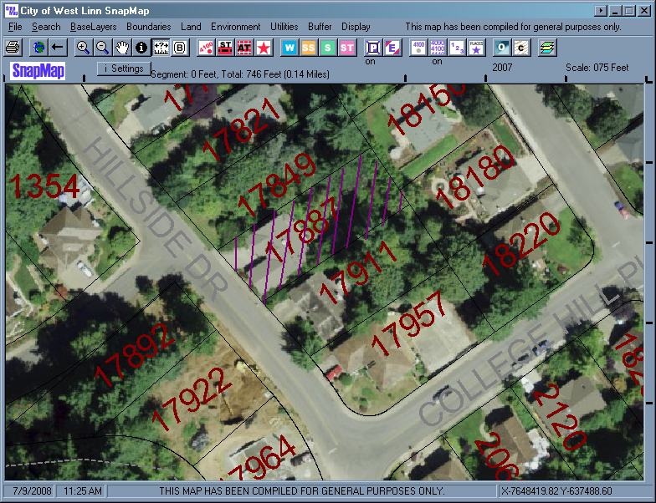
Office Use Only:
Pre-application Referal Response Due By : July 14, 2008 or bring to conference meeting.

