CITY OF WEST LINN
LAND USE PRE-APP CONFERENCE MEETINGS
THURSDAY, JULY 3
CITY HALL
22500 SALAMO RD
WILLAMETTE CONFERENCE ROOM

9:00 a.m. 11 Lot PUD
1329 & 1335 Willamette Falls Drive
Dave and Vikki Gackle
(Willamette Neighborhood Assoc.)
PA-08-23 Planner: Tom Soppe

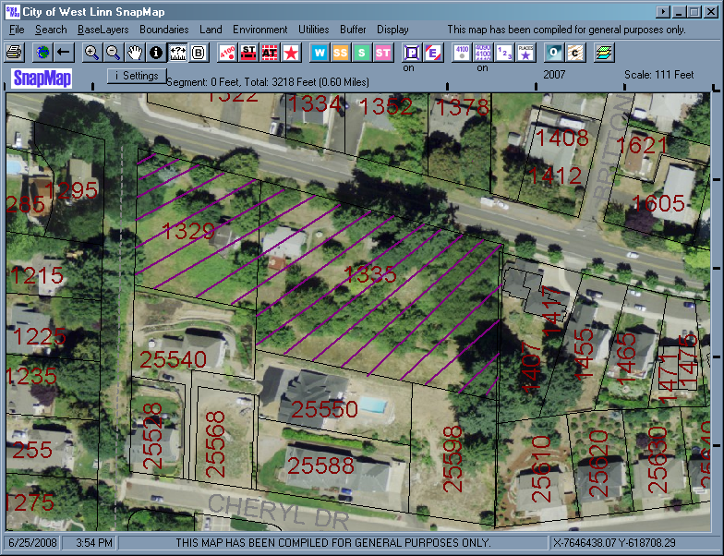
Office Use Only:
Pre-application Referal Response Due By : June 30, 2008 or bring to conference meeting.

