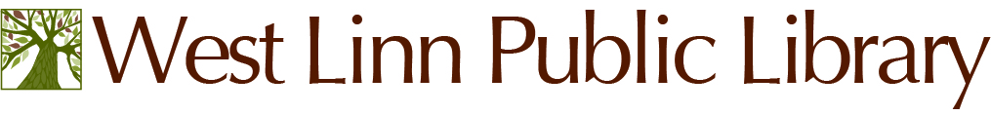
MEETING NOTICE
Library Advisory Board
______________________________________________________________________
Wednesday – November 16, 2016 - 5:45 P.M.
City of West Linn Public Library
- Burns St., West Linn, OR 97068
West Linn Library Community Room

- Call to Order, Minutes Review (9-21-16)

- Agenda Review-

- Public Comments-

- Library Director’s Comments & Report-

- Friends Update-

- Foundation Update-

- Board Comments-

- Adjournment-

Upcoming Meetings: Wednesday – December 21, 2016 – 5:45 pm
_________________________________________________________________________________________________________

For special assistance under the Americans with Disabilities Act, please call City Hall 48 hours prior to the meeting date, 503-657-0331 or TDD 503-657-7845. _________________________________________________________________________________________________________
The mission of the West Linn Public Library is to: engage, connect and inspire our community and to be a
resource for information, knowledge, and artistic and literary expression, providing the best in
traditional services, new technologies and innovative programs.
The mission of the West Linn Public Library is to: engage, connect and inspire our community and to be a
resource for information, knowledge, and artistic and literary expression, providing the best in
traditional services, new technologies and innovative programs.
The mission of the West Linn Public Library is to: engage, connect and inspire our community and to be a
resource for information, knowledge, and artistic and literary expression, providing the best in
traditional services, new technologies and innovative programs.
The mission of the West Linn Public Library is to: engage, connect and inspire our community and to be a resource for information, knowledge, and artistic and literary expression, providing the best in traditional services, new technologies and innovative programs.
The mission of the West Linn Public Library is to: engage, connect and inspire our community and to be a
resource for information, knowledge, and artistic and literary expression, providing the best in
traditional services, new technologies and innovative programs.

