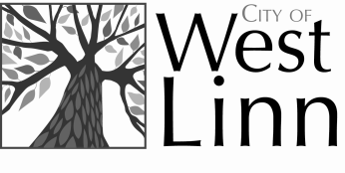
Report Back to Committee for Grant Program
[for events/programs held July 1, 2015 through June 30, 2016]

Instructions for Applicants:

- Refer to “Application for Community Grant Program” for application information

- Refer to “Criteria for Community Grant Program” for guidelines and criteria

- In the interest of sustainability, this Report Back Form should be completed and submitted electronically reporting back the uses of your grant funds and the successes of your program within 90 days of your event/program was complete.

- Email to cwl_communitygrants@westlinnoregon.gov within 90 days after event/program.

- Organizations receiving grant funds must complete this Report Back to Committee form within 90 days after event/program is completed in order to be eligible for future grant funding.

Applicant Contact Information

Organization Name: .
Primary Contact Person: .
Email: .
Address: .
Telephone: .
Web Site: .
Amount Awarded and Received : $ .

How Our Grant benefited the Citizens of West Linn:

- How did the funds help the purpose of your organization (i.e., Event A brought new education and activities to West Linn encouraging happiness and wellbeing for teens)?
.
.
.
.
.
.

- What value did the grant program provide to the citizens of West Linn (i.e., 25 West Linn teens attended Event A for free)?
.
.
.
.
.
.

- Please describe how any previously received grant funds were used (if any), (i.e., $500 motivational speaker, $1,000 activity booths for yoga/karate/sewing/gardening):
.
.
.
.
.
.

Signature Certification

I affirm that if my organization is granted funding, my organization will be required to adhere to City guidelines related to the use of funds, and will be required to provide timely reporting on the use of the granted funds to the City of West Linn. I affirm that the grant funds will only be used for the intentions outlined for this program.
(Please type your name, title, and date; upon receipt of funds, a final signature will be required)

. .
Signature & Title Date

